

Customer Segmentation Using the Online Retail II Dataset
Digital Assignment 2

Submitted by
Suyash Agrawaal (Reg No. – 24BDS1167)

Under the Guidance of
Course Faculty: Dr. Meignanamoorthi D
Course: Programming for Data Science (BCSE207L)
Class Number: CH2026270100997
Slot: G1
Semester: Fall Semester 2026-2027

School of Computer Science and Engineering
Vellore Institute of Technology, Chennai

INDEX

Abstract | 4
1. Introduction | 5
1.1 Background and Scope | 5
1.2 Objectives of This Phase | 5
1.3 Tools and Environment | 5
2. Feature Engineering and Feature Selection | 6
2.1 Source Data Preparation | 6
2.2 RFM Feature Construction | 7
2.3 Target Variable Definition | 8
2.4 Preventing Data Leakage | 9
2.5 Categorical Encoding | 10
2.6 Feature Selection | 10
3. Database Connectivity and Data Retrieval | 11
3.1 Choice of Database | 11
3.2 Normalized Schema Design | 11
3.3 Populating the Database from R | 12
3.4 Indexing and Query Performance | 13
3.5 Data Retrieval in Python | 14
3.6 Analytical SQL Queries | 15
3.7 SQL versus In-Memory Processing | 21
3.8 Writing Model Output Back to the Database | 23
4. Implementation of Machine Learning and Deep Learning Algorithms | 25
4.1 Modelling Setup | 25
4.2 Algorithms Implemented | 26
4.3 Churn Prediction Results | 27
4.4 High-Value Customer Prediction | 28
4.5 Customer Segment Classification | 29
4.6 Stacking Ensemble | 30
5. Hyperparameter Tuning and Model Optimization | 31
5.1 Grid Search with Cross-Validation | 31
5.2 Decision Threshold Optimization | 32
5.3 Class Imbalance Handling with SMOTE | 33
6. Comparative Performance Analysis | 35
6.1 Evaluation Metrics | 35
6.2 Consolidated Model Comparison | 35
6.3 Cross-Validation Stability | 36
6.4 Statistical Significance Testing | 37
6.5 Key Observations | 38
7. Comparative Visualizations | 39
7.1 ROC Curves | 39
7.2 Precision-Recall Curves | 40
7.3 Confusion Matrices | 41
7.4 Feature Importance | 42
7.5 SHAP Explainability | 42
7.6 Learning Curves | 44
7.7 Probability Calibration | 45
7.8 Customer Segment Visualization | 45
8. Demonstration of Business Output | 48
9. Conclusion | 50
10. References | 51

Abstract
This report details the second stage in the customer segmentation project using the Online Retail II dataset. While DA1 focused on initial data cleaning and preparation, this stage involved transforming the cleaned data into customer-based features and applying it for prediction and segmentation purposes. The resulting database comprised 779,425 cleaned transactions and was used to generate customer-level behavioural features for 5,281 customers.
The majority of customer-level features were recency, frequency and monetary (RFM)-based. Features included average order value, average quantity, total quantity and bulk-order activity. The analysis focused on three tasks: prediction of customer churn, identification of high-value customers and grouping customers into behavioural segments. A time-based split was used for predicting churn to ensure that future transactions were not used for creating the input features.
The customer data was stored in a normalized SQLite database. R was used for feature engineering and database creation, while Python was used for model training, evaluation and SQL-based analysis. In total, 24 models were tested for all three tasks. For the task of churn prediction, the neural network achieved a ROC-AUC of 0.807, while the stacking model scored 0.809. Threshold tuning increased churn recall from 0.809 to 0.873. The application of SMOTE was also tested for the high-value prediction task, where minority-class recall for Logistic Regression increased from 0.814 to 0.958.
The results were evaluated using ROC curves, precision-recall curves, confusion matrices, feature importance, SHAP values, learning curves and calibration plots. Additionally, the final predictions were stored back in the database to enable analysis of customer risk using SQL.
Keywords: Customer segmentation, RFM-based customer analysis, customer churn modelling, machine learning, K-Means clustering, SQLite, Python, R, SHAP, SMOTE.

1. Introduction

1.1 Background and Scope

DA1 was used as a basis for this stage of the project. The two sheets of the Online Retail II dataset were merged and preprocessed prior to performing the first analysis. As a result, there were 779,425 valid transaction records from 5,878 identified customers.

As it is evident from the database, the initial data was structured at the level of transactions and product lines and thus did not include any information on customers. In the scope of this stage, the transactions were aggregated in order to be able to assess behaviour at the customer level. Thus, the transactions were cleaned and formed into groups corresponding to individual customers, which resulted in a single record for each customer. The resulting records were used for storage in the database, customer segmentation, and prediction purposes.

The questions the analysis was intended to address were whether a customer would churn, whether a customer was high-value, and which segment the customer belonged to.

1.2 Objectives of This Phase

The goals of this phase were to:

• transform transactional data to customer-level features

• engineer RFM-based features and choose the right variables for each prediction task

• prepare a normalized SQLite database and access it in R and Python

• apply various machine learning and deep learning algorithms for customer prediction tasks

• tune the best-performing models using hyperparameter optimization, threshold tuning, and SMOTE

• evaluate the final ML models using accuracy, precision, recall, F1-score, and ROC-AUC metrics

• visualize insights and model performance to interpret results and customer behavior

• showcase how the final prediction results can be stored and accessed in the SQLite database.

1.3 Tools and Environment
Component | Tool / Library | Purpose
Feature engineering | R 4.6 - dplyr, lubridate, readxl | Data loading, cleaning and RFM aggregation
Database | SQLite with DBI and RSQLite (R), sqlite3 (Python) | Storage, integrity constraints and SQL analysis
Modelling | Python 3 - scikit-learn, XGBoost, LightGBM | Classification algorithms and evaluation
Optimisation | GridSearchCV, imbalanced-learn (SMOTE) | Hyperparameter tuning and class balancing
Analysis | SHAP, statsmodels | Model explanation and significance testing
Visualization | matplotlib, SHAP plots | Comparative charts
Environment | RStudio (local), Google Colab | Execution
Version control | Git and GitHub | Code and output management
Table 1: Tools and libraries used in this phase

2. Feature Engineering and Feature Selection
This step involved transforming the data to a set where each row represents a customer. This was achieved by aggregating all the previous transactions for each customer. Initially, the data consisted of a great number of rows representing single transactions, while the prediction models require each customer to be represented by a row. Grouping was performed within the customer ID, after which behavioural measures were calculated.
All feature engineering steps for this phase were carried out in R, using DA2_Phase1_FeatureEngineering_Database.R.
2.1 Source Data Preparation
The data cleaning steps performed in DA1 were repeated in this section, in order to prepare the data for feature engineering. This allowed ensuring that both phases used the same cleaned data set.
The same cleaning steps were applied, including the removal of records with missing customer IDs, duplicates, cancelled invoices, negative quantities, and prices, as well as the creation of the bulk-order flag, based on the interquartile range, as in DA1. As a result, 779,425 rows were obtained, which is the same number as in DA1.

Code:
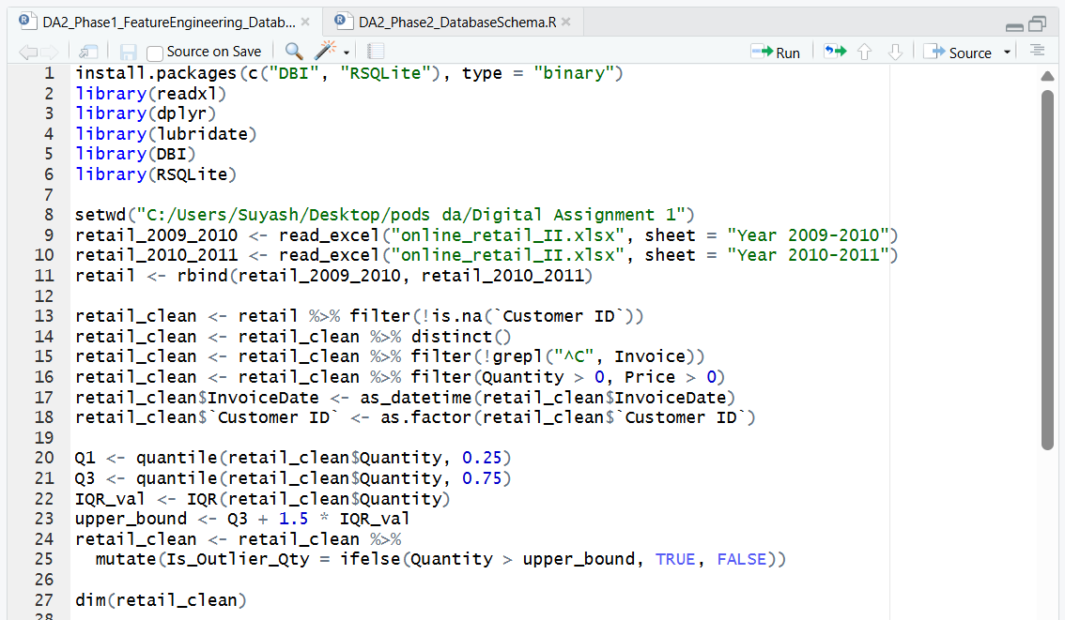
Output:
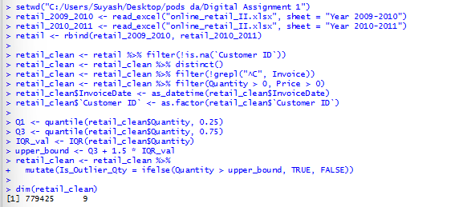

2.2 RFM Feature Construction

The method of RFM analysis was used as a basis for the assessment of customer behaviour. The three main dimensions comprising this model are known as Recency, Frequency and Monetary value (RFM). Collectively, these RFM variables aim to incorporate the time of a customer’s purchase, their purchase frequency and their spending power.

In addition to the three key variables, four additional dimensions were introduced to evaluate the size of order and other purchasing patterns. Following the application of the cut-off date and processing of transaction data, there was obtained one record for each of the 5,281 customers.

Such a format allows the models using this data to operate on a per-customer basis rather than per-row basis.

Code:
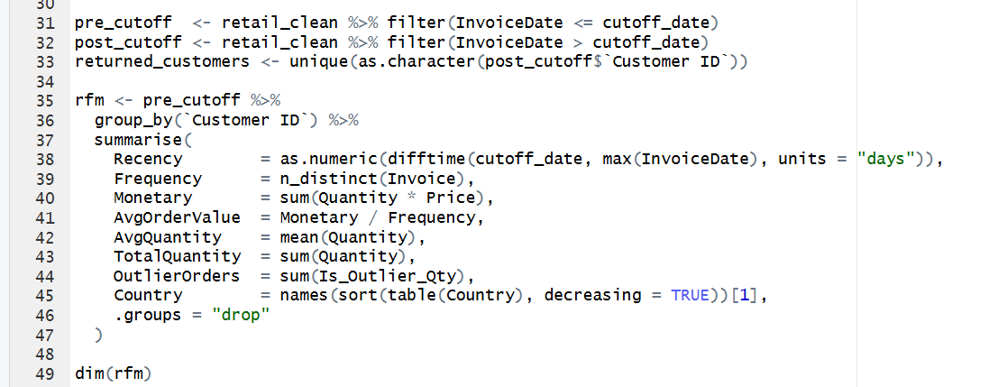
Output:
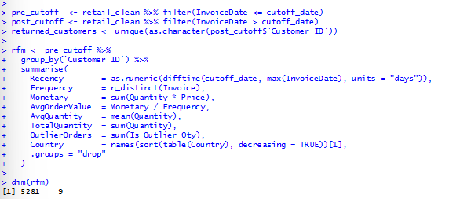
Feature | Definition | Behaviour Captured
Recency | Days between the customer's last purchase and the cutoff date | How recently the customer engaged
Frequency | Number of distinct invoices | How often the customer buys
Monetary | Total spend (Quantity x Price) | Lifetime value to the business
AvgOrderValue | Monetary / Frequency | Typical basket value
AvgQuantity | Mean units per transaction line | Typical order size
TotalQuantity | Total units purchased | Overall purchasing volume
OutlierOrders | Count of lines flagged as bulk orders in DA1 | Wholesale-type purchasing
Country | Most frequent country for the customer | Geographic market
Table 2: Engineered customer-level features

The rationale behind keeping the Outlier Orders is that in this particular dataset, a big order is not necessarily a mistake since the retailer also targets those who tend to shop in bulk. Therefore, all orders that exceeded the threshold were flagged as outliers, and the flag was turned into an additional customer-level feature.
Figure 3. Exploratory Data Analysis Plots for the First Three Features in the Customer Level Table.
2.3. Target Variable Definition
There were three target variables created for the three types of predictions. Churn is a binary variable indicating if a customer made any purchase after the cut-off date. HighValue means a customer is in the top 20% in terms of Monetary value, and Segment is a categorical variable retrieved from K-Means clustering with four clusters. The description of the class distribution is given in Table 3.

Code:
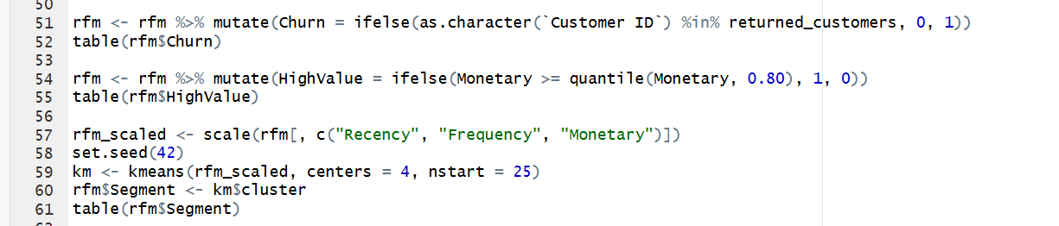
Output:
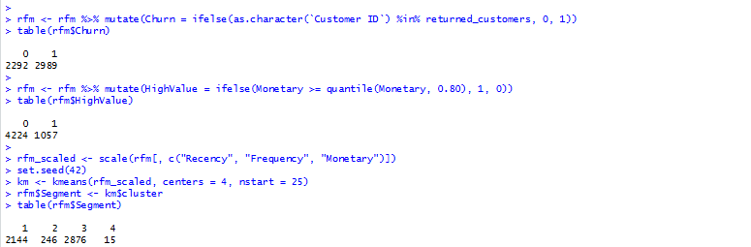
Target | Definition | Type | Class Distribution
Churn | No purchase in the 90 days after the cutoff | Binary | 2,989 churned / 2,292 retained
HighValue | Top 20% of customers by Monetary | Binary | 1,057 high-value / 4,224 standard
Segment | K-Means cluster (k = 4) on scaled RFM | Multi-class | 2,144 / 246 / 2,876 / 15
Table 3: Target variables and class distributions

The targets have significantly different balances. Churn is close to be balanced, HighValue is imbalanced with a ratio of approximately four to one by design, and Segment is highly imbalanced with one cluster of only 15 customers. This has influenced the choice of the performance metrics that will be presented later in the report.

2.4 Preventing Data Leakage
When I tried to make the first modelling attempts, I noticed that the churn label was created on Recency, and all customers with Recency of more than 90 days were marked as churned. This means that the models could simply learn the same rule and always return a positive prediction if Recency is higher than 90, which would explain 100% accuracy.
Actually, this was the result of the data leakage, and I decided to make adjustments to prevent it. Instead of using the whole dataframe, I split it according to the time of when the prediction was made. As a result, the features were calculated using only the transactions that occurred before the cutoff date, and the label was defined as whether the customer made any repeat purchase in the following period.
Code:
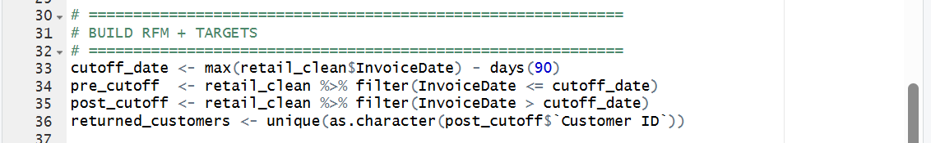
After applying this transformation, the precision rate decreased to around 70-74%. While the new score is significantly worse than the previous one, it provides a more accurate estimation of our model's performance on unseen customer's data. Note that the customer base shrank from 5,878 to 5,281 as we only consider customers that were active before the cut-off point and for whom we can calculate features.
For the HighValue task, Monetary and AvgOrderValue were also removed from the model inputs because the target itself is based on Monetary value.

2.5 Categorical Encoding

The Country variable consists of more than 40 unique values, some of which contain only a few customers. Applying all the categories would generate many sparse variables.

To reduce the dimensionality, only the five most frequent countries were kept, and all the others were merged into 1 category called Other. The resulting variable was then one-hot encoded using Python.
Code:

2.6 Feature Selection
Features were selected against two criteria: each feature must describe customer behaviour, and no feature may directly encode the label it is used to predict.
Feature | Churn | High-Value | Segment | Reason
Recency, Frequency | Yes | Yes | Yes | Core behavioural signals
Monetary, AvgOrderValue | Yes | No | Yes | Excluded from High-Value to prevent leakage
AvgQuantity, TotalQuantity | Yes | Yes | Yes | Independent engagement measures
OutlierOrders | Yes | Yes | No | Bulk-purchasing behaviour
CountryGroup (encoded) | Yes | Yes | No | Geographic variation observed in DA1
Customer ID | No | No | No | Identifier with no predictive meaning
Table 4: Feature selection by prediction task

The final churn dataset consists of twelve input columns. Most of these variables describe the customer purchasing behavior; five columns represent the grouped country information. The model interpretation results described in Chapter 7 were also used to check which of these features contributed most in the predictions.

3.Database Connectivity and Data Retrieval
The database was used as part of the project workflow, not only as storage for the final results. R was used to create the customer, product and transaction tables. Python then connected to the same SQLite database for modelling and SQL analysis, and after prediction, the model results were written back into the database.
The database schema was created using DA2_Phase2_DatabaseSchema.R, while the retrieval and analytical queries were carried out in DA2_ML_Models.ipynb

3.1 Choice of Database
SQLite was selected for this project because the database could be contained in one file without requiring a separate server. One reason for choosing SQLite was that the whole database can be contained in a single file and does not require a separate server.
Another practical advantage was that the same database could be accessed from both R and Python. R could access the database through DBI and RSQLite, while Python could use the built-in sqlite3 module. This made it convenient to move the same database between RStudio and Google Colab.
As the project data is divided into customers, products and transactions, a relational database was suitable for the required joins and SQL queries.

3.2 Normalized Schema Design
The database tables were created manually rather than simply exporting the R data frames as flat tables. Primary keys, foreign keys and CHECK constraints were added to maintain data consistency
For example, the transactions table checks that quantity and price are not negative. Foreign keys ensure that a transaction refers to an existing customer and product.
Code:
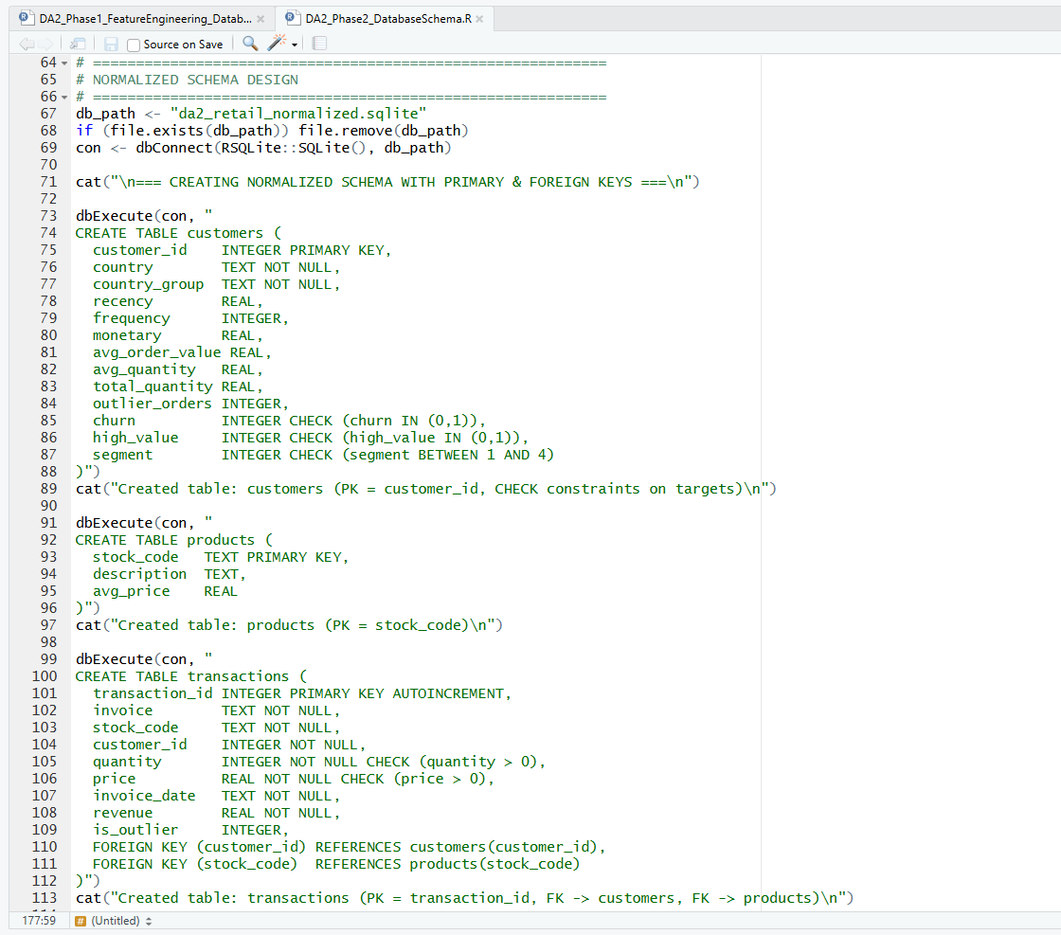
Output:
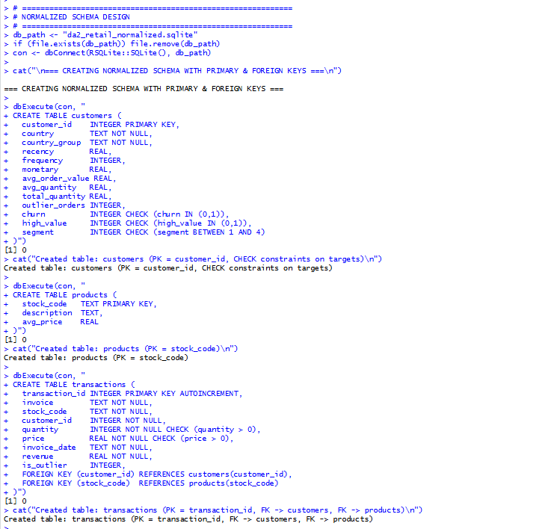
Table | Rows | Keys and Constraints | Written By
customers | 5,281 | Primary key on customer_id; CHECK on churn, high_value, segment | R
products | 4,631 | Primary key on stock_code | R
transactions | 752,407 | Primary key; foreign keys to customers and products; CHECK on quantity and price | R
ml_predictions | 5,281 | Primary key; foreign key to customers | Python
Table 5: Structure of the normalized database

3.3 Populating the Database from R

Each table was populated using objects created in R. The transactions table was limited to customers who are present in the customers table, so that each foreign key reference is valid. The result shows 5,281 customers, 4,631 products and 752,407 transactions.

Code:
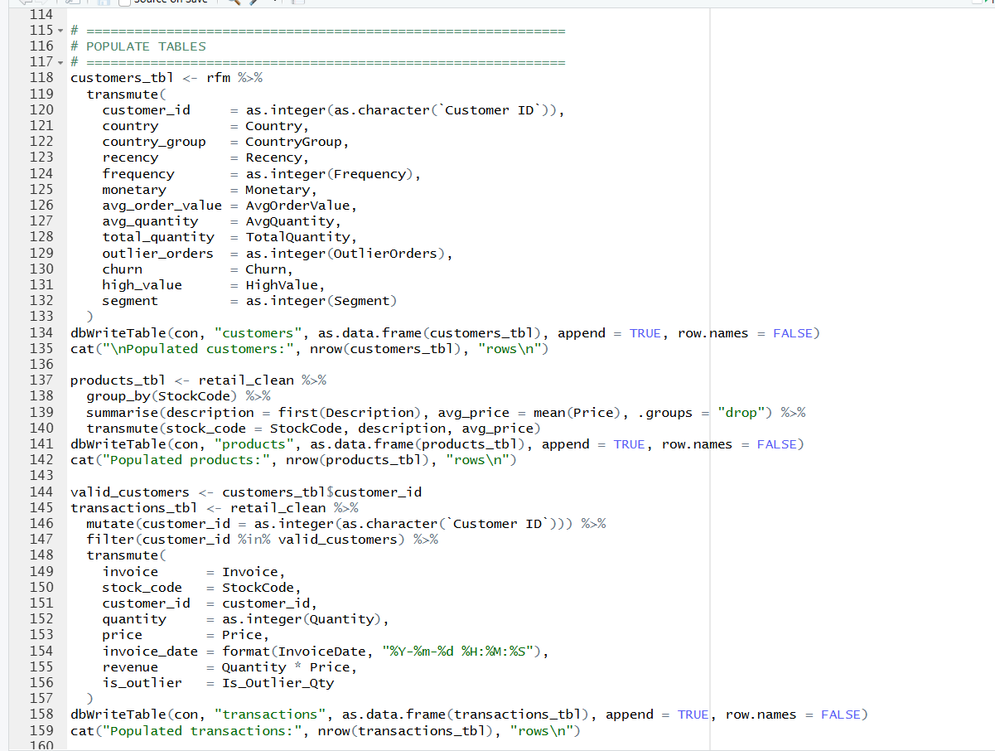
Output:
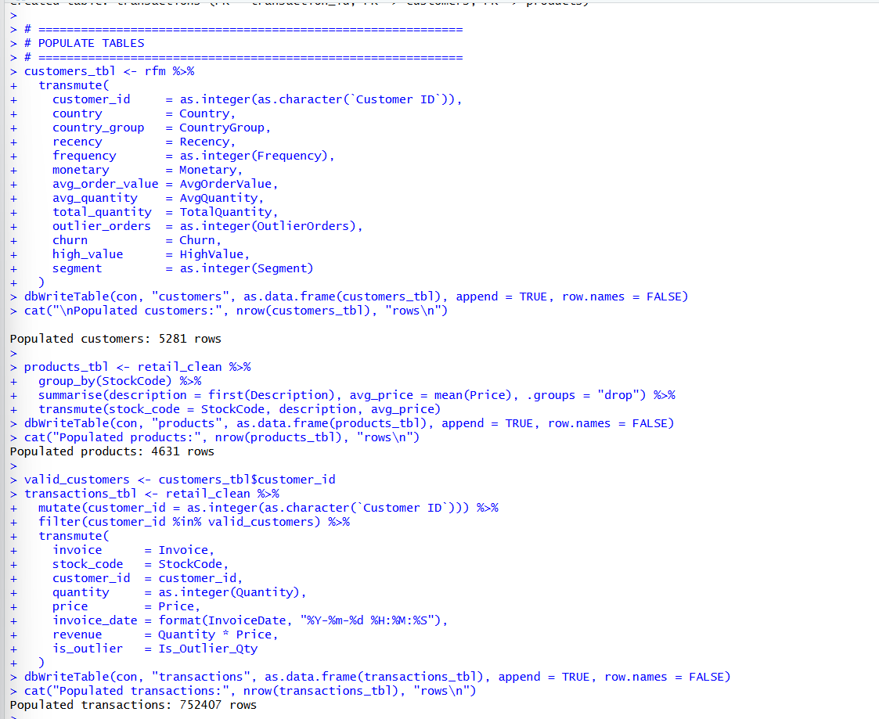

3.4 Indexing and Query Performance

Five indexes were created on the columns most heavily used for joins and where filters are applied. To check if it actually makes a difference, the same join-and-aggregate query was timed with and without them. As can be seen in the output, the query with the indexes performed noticeably faster, and the schema summary shows all tables and indexes in the database.

Code:
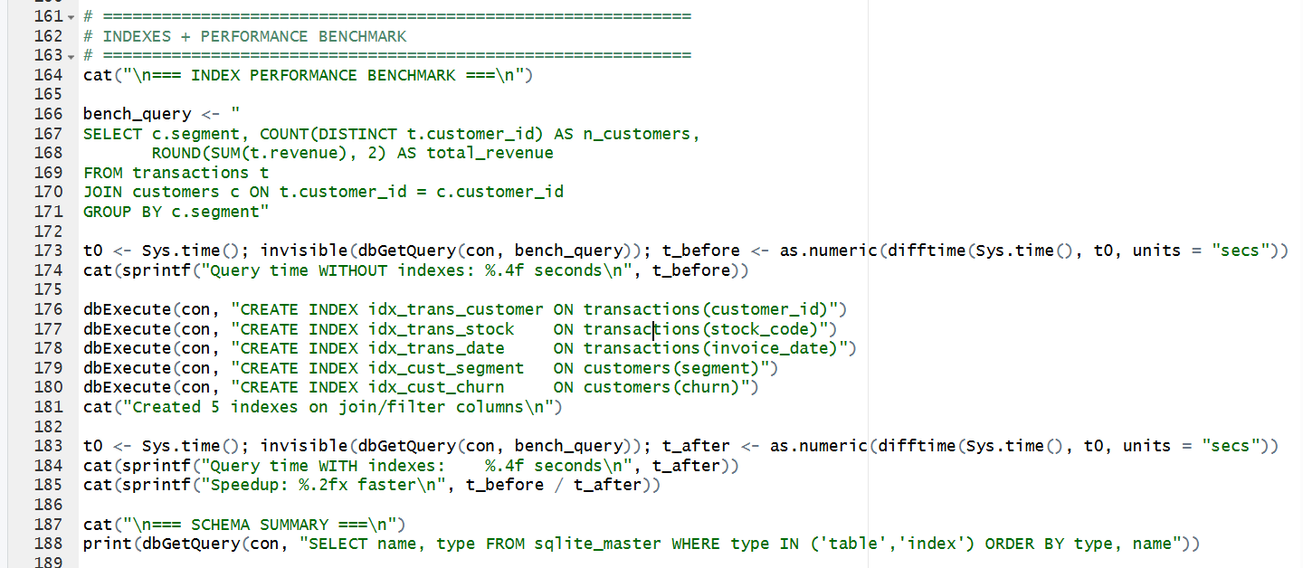
Output:
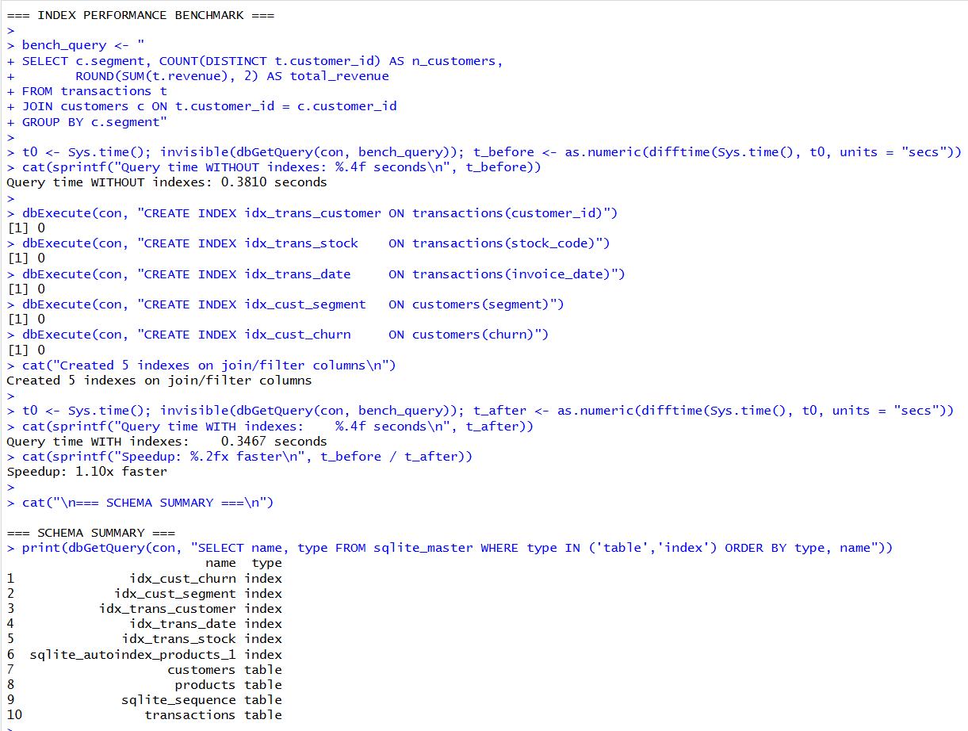

3.5 Data Retrieval in Python

The database file was opened up with Google Colab via Python's sqlite3 module to check if the same 5,281 customer records that R has put there are indeed found by the new language, which proves that it works as a reliable interface between the two.
Code:
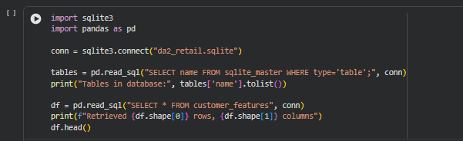
Output:
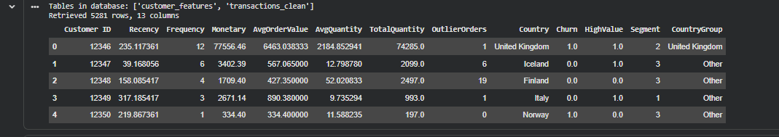

3.6 Analytical SQL Queries

Nine analytical queries were run from Python. They jointly span joins of multiple tables, aggregations, date manipulations, a subquery, a window function and parameterised input. A small helper function prints each query and returns its result as a data frame; the first query uses it to summarise the schema.
Code:
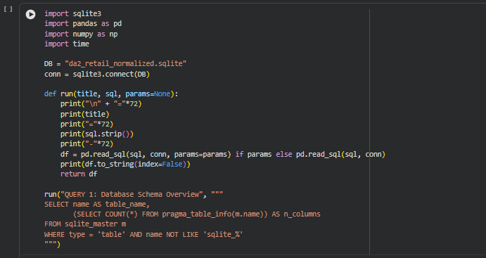
Output:
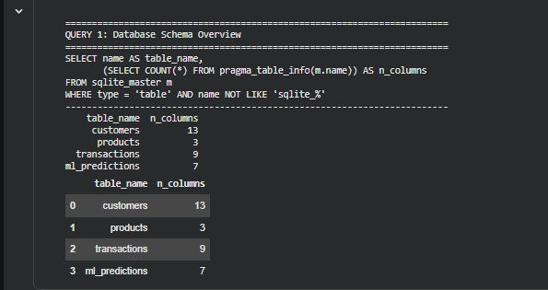
No. | Query Purpose | SQL Technique
Q1 | Schema overview: tables and column counts | System catalogue, pragma_table_info
Q2 | Revenue and customer count per segment | JOIN, GROUP BY, aggregation
Q3 | Top ten products by revenue | JOIN, GROUP BY, ORDER BY, LIMIT
Q4 | Churn rate by country group | Calculated percentage field
Q5 | Monthly revenue trend | String-based date grouping
Q6 | High-value customers above twice the average spend | Scalar subquery
Q7 | Top two products within each segment | Window function ROW_NUMBER() OVER PARTITION BY
Q8 | Customers filtered by segment and spend | Parameterised query
Q9 | Behavioural comparison of churned and retained customers | CASE expression with aggregation
Table 6: Summary of analytical SQL queries

Query 2 - Revenue and customers per segment

This query was run to compare the four customer segments. It joins the transaction and customer tables and calculates the number of customers, total revenue and average revenue-related figures for each segment.
Code:
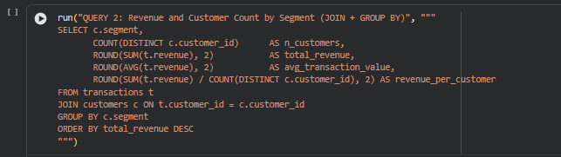
Output:
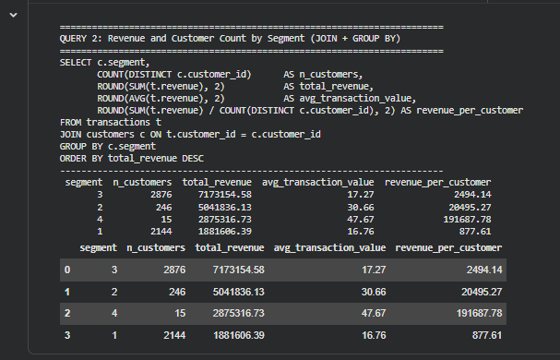

Query 3 - Top products by revenue

Query 3 determines the products with the highest revenue and also indicates their units sold and customer count. The result also highlights the number of units sold and different customers that purchased each product.

Code:
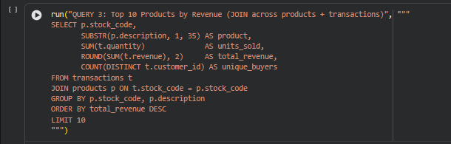
Output:
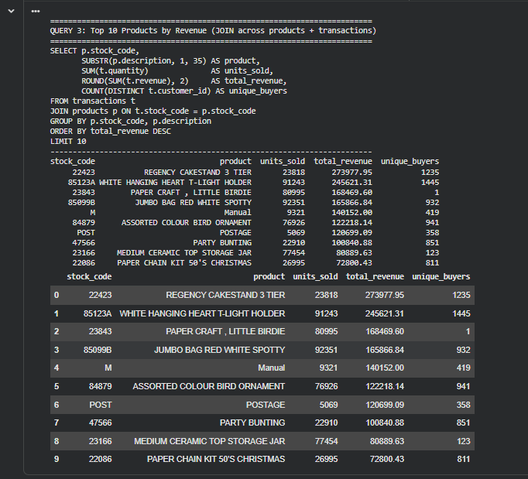

Query 4 - Churn rate by country group
Query 4 organizes customers into groups according to their country group and then measures the corresponding churn rate. Multiplying by 100.0 guarantees that the division will provide a decimal rather than an integer value.

Code:
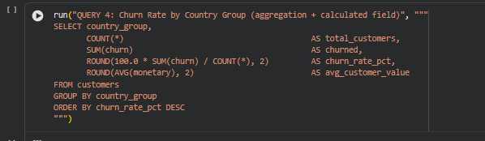
Output:
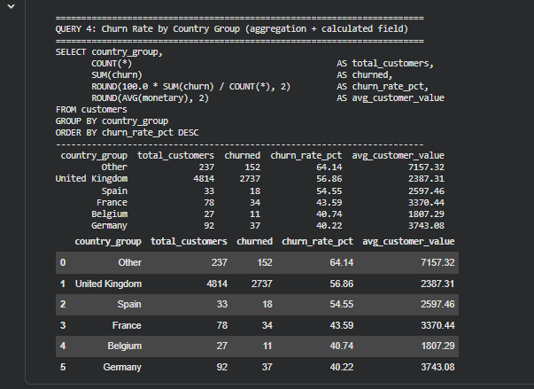

Query 5 - Monthly revenue trend

In Query 5, the invoice dates were transformed into year-month values in order to enable comparisons of monthly counts and revenues. This allowed for making comparisons between the number of orders and total revenue from one month to the next.
Code:
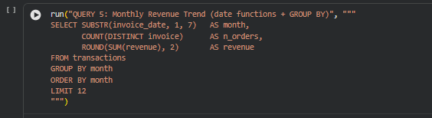
Output:
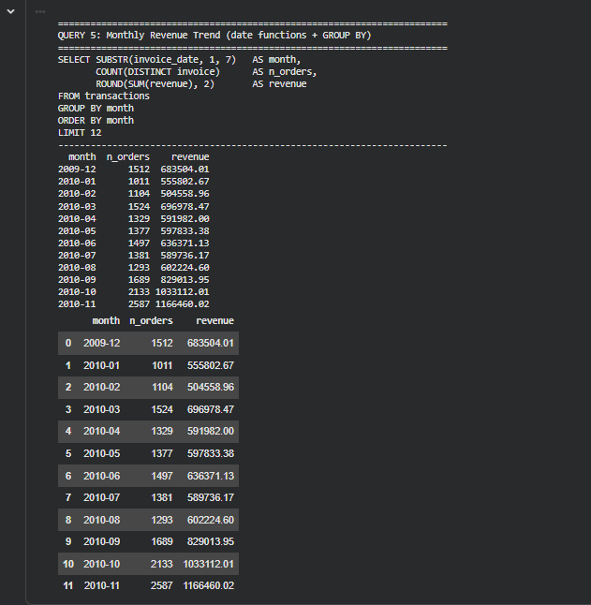

Query 6 - High-value customers using a subquery

This query employs a subquery to compute the average spend of customers, and then the outer query returns those customers whose spending exceeded this average by more than 2 times.
Code:
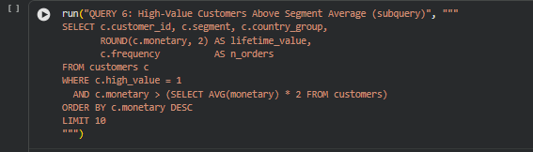
Output:
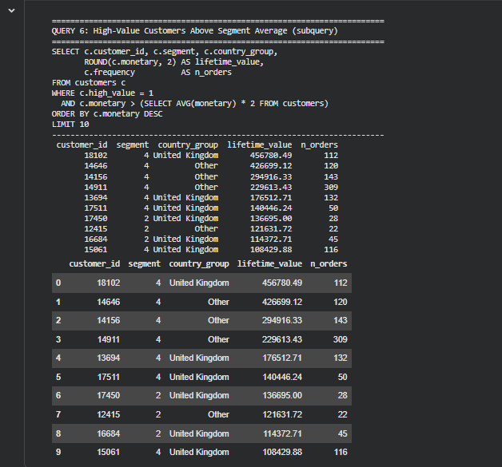

Query 7 - Top products per segment using a window function

ROW_NUMBER() window function was used to rank the products within each customer segment, thus enabling the extraction of the top 2 products in each segment in a single query.
Code:
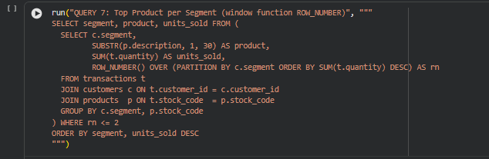
Output:
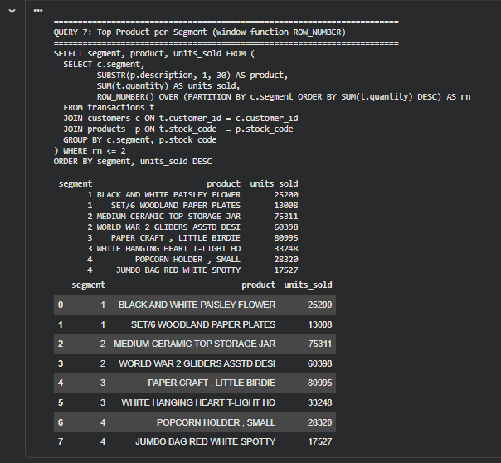

Query 8 - Parameterised query
The segment number and spending threshold are provided separately from the SQL statement, thus isolating the user input from the actual SQL code and preventing any potential injection attacks that would involve placing values directly into the query text.
Code:
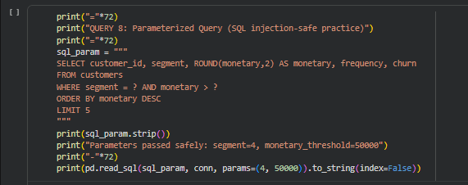
Output:
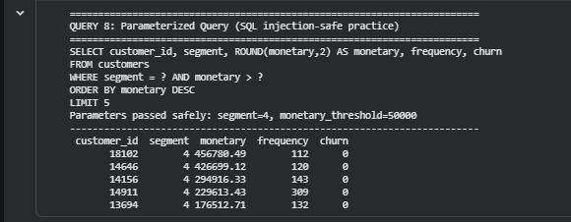

Query 9 - Churned versus retained customers

The final query compares the characteristics of churned and retained customers using average Recency, Frequency and Monetary values. A CASE expression was used to define the two customer groups.
Code:
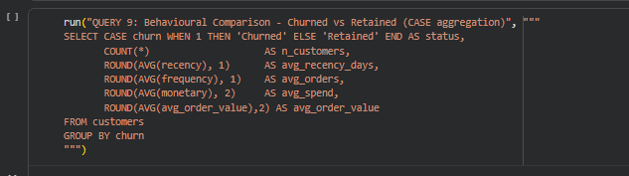
Output:
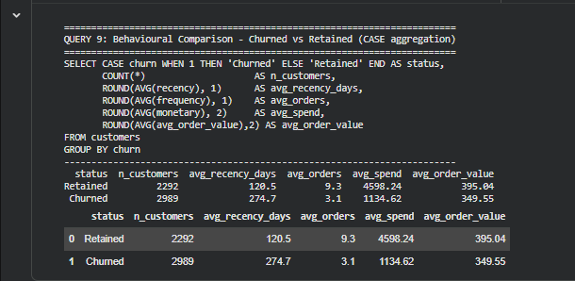
The customers retained continued to order more frequently (about three times more often), spent more (about four times more), and were last seen less than half as long as customers who churned. These metrics are clear indicators of churn.

3.7 SQL versus In-Memory Processing
To evaluate database performance, the same calculation was run in two different ways. First, to see how it compares with typical in-memory computation, the entire calculation was carried out directly in SQLite via SQL queries.
Then, the data was loaded into pandas and aggregated there.
Code:
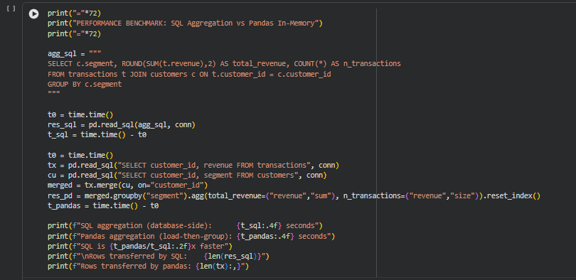
Output:
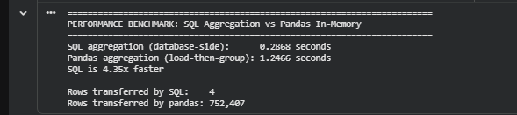
The results were then plotted to compare execution time and the number of rows transferred.
Code:
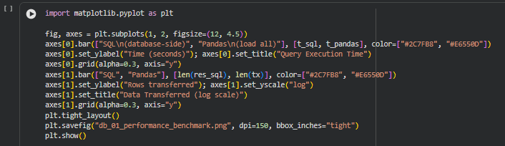
Output:
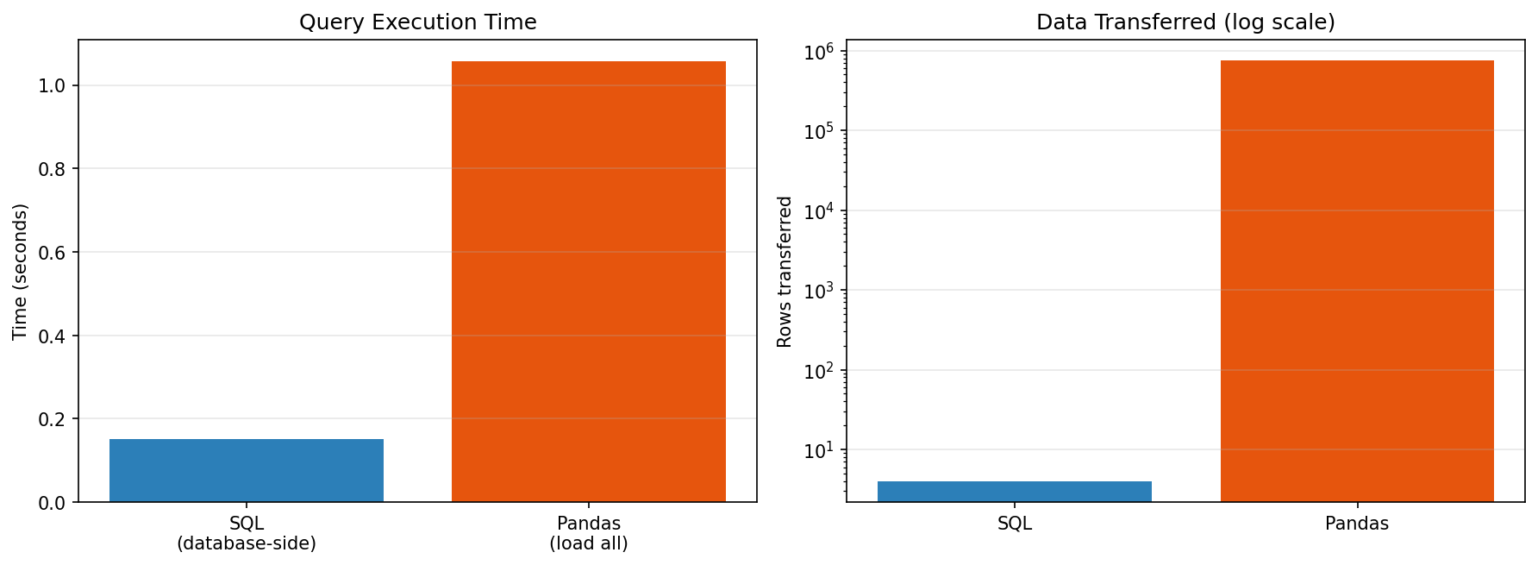

The SQL query only retrieved four summary rows while the pandas approach had to pass all 752,407 transaction rows before being able to perform the aggregate. On this dataset, the SQL version also finished faster.
The difference is only about one second for this dataset but the amount of data that has to be passed is significantly higher when the whole transaction table is loaded into memory.

3.8 Writing Model Output Back to the Database
In order to make a round-trip, the Python read the customers table written by R, trained a Gradient Boosting model and wrote each customer's churn probability back into the database as a new table, ml_predictions, which is related to customers through a foreign key.
Customers have been placed into Low, Medium and High risk bands and the optimised decision threshold from Section 5.2 has been used for the predicted label.

Code:
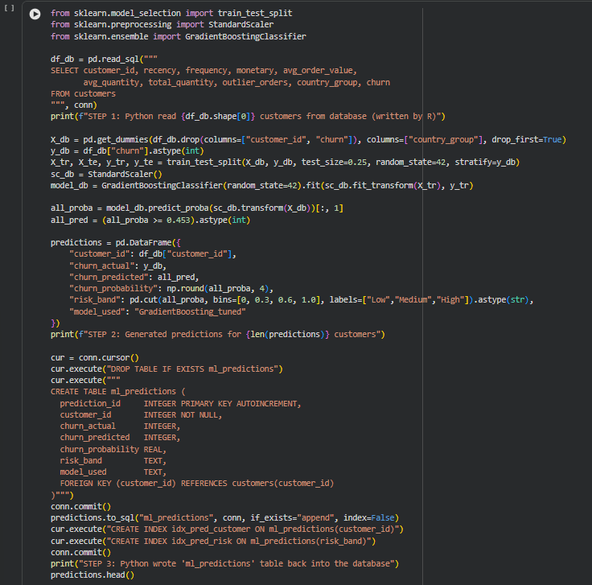
Output:
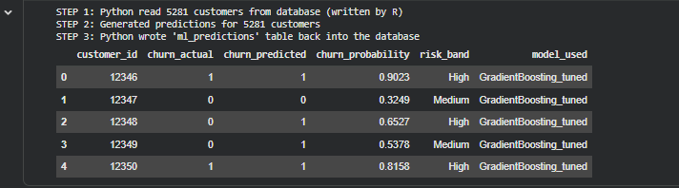
A final check lists the contents of the database. It now holds four tables and seven indexes, which confirms that data has flowed from R to SQLite to Python and back again.
Code:
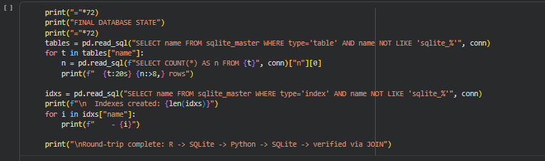
Output:
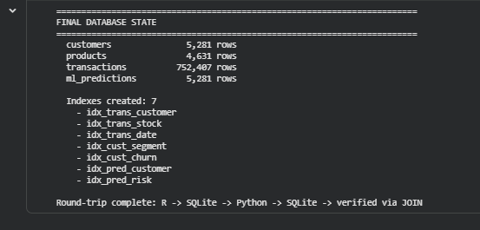

4. Implementation of Machine Learning and Deep Learning Algorithms
In total there were 24 models trained for the three prediction tasks. 13 models were used for churn prediction, 6 models for high-value customer prediction and 5 models for customer segment classification. We also made a stacking model using the best performing churn models.
All model training and evaluation was done in Python using DA2_ML_Models.ipynb.

4.1 Modelling Setup
For the churn prediction we trained all models using the same stratified 75/25 train-test split. We used stratifying so that the proportion of churned and retained customers was close to the same in the two sets.
The scaler was fitted using only the training data before transforming the test data, to ensure that the test data would not contain any information that would not be available when making predictions.
The split gave us 3,960 customers to use for training and 1,321 customers to use for testing. We had twelve features to use for each customer.

Code:
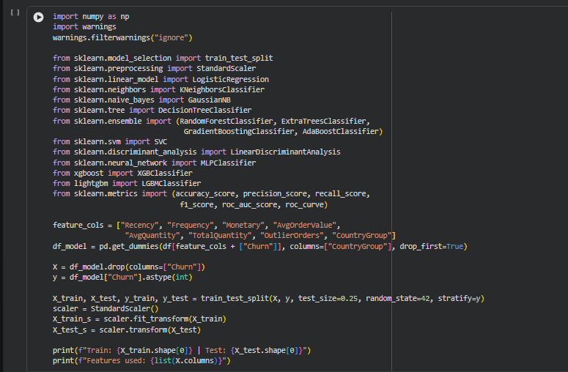
Output:

4.2 Algorithms Implemented
A variety of model types was included to allow the comparison of their performance on the same data set. The models range from relatively simple algorithms, such as Logistic Regression and Naive Bayes, through tree-based approaches, including Random Forest, XGBoost, LightGBM, and a neural network.
No. | Algorithm | Family | Key Configuration
1 | Logistic Regression | Linear | max_iter = 1000
2 | Linear Discriminant Analysis | Linear | Default
3 | K-Nearest Neighbors | Instance-based | k = 7
4 | Gaussian Naive Bayes | Probabilistic | Default
5 | Support Vector Machine | Kernel | RBF kernel, probability = True
6 | Decision Tree | Tree | max_depth = 8
7 | Random Forest | Bagging ensemble | 200 trees
8 | Extra Trees | Bagging ensemble | 200 trees
9 | AdaBoost | Boosting ensemble | Default
10 | Gradient Boosting | Boosting ensemble | Default
11 | XGBoost | Boosting ensemble | eval_metric = logloss
12 | LightGBM | Boosting ensemble | Default
13 | Neural Network (MLP) | Deep learning | Hidden layers (32, 16), max_iter = 500
Table 7: Algorithms implemented for churn prediction
All thirteen churn models were evaluated using the same set of metrics: accuracy, precision, recall, F1-score and ROC-AUC. The models were trained and evaluated in a single loop.
Code:
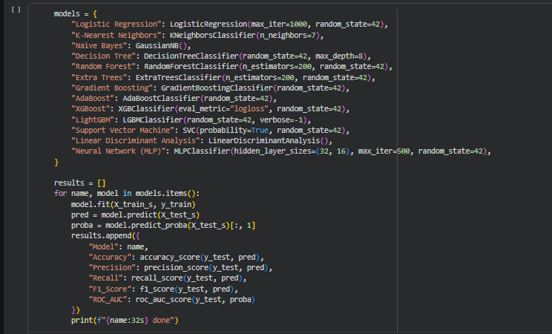
Output:
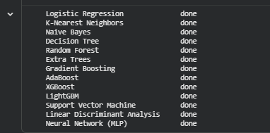

4.3 Churn Prediction Results
Rank | Model | Accuracy | Precision | Recall | F1 | ROC-AUC
1 | Neural Network (MLP) | 0.744 | 0.759 | 0.802 | 0.780 | 0.807
2 | Gradient Boosting | 0.728 | 0.737 | 0.809 | 0.771 | 0.805
3 | Logistic Regression | 0.737 | 0.760 | 0.782 | 0.771 | 0.797
4 | AdaBoost | 0.724 | 0.741 | 0.790 | 0.765 | 0.794
5 | Linear Discriminant Analysis | 0.721 | 0.764 | 0.734 | 0.748 | 0.789
6 | Support Vector Machine | 0.734 | 0.726 | 0.850 | 0.783 | 0.787
7 | Extra Trees | 0.724 | 0.743 | 0.785 | 0.763 | 0.787
8 | Random Forest | 0.722 | 0.738 | 0.790 | 0.763 | 0.787
9 | LightGBM | 0.718 | 0.733 | 0.791 | 0.761 | 0.787
10 | XGBoost | 0.706 | 0.725 | 0.774 | 0.749 | 0.772
11 | Naive Bayes | 0.640 | 0.618 | 0.957 | 0.751 | 0.771
12 | K-Nearest Neighbors | 0.717 | 0.734 | 0.783 | 0.758 | 0.767
13 | Decision Tree | 0.705 | 0.728 | 0.763 | 0.745 | 0.740
Table 8: Churn prediction results on the test set, ranked by ROC-AUC
The test results are provided in Table 8. Thus, the best-performing model is Neural Network (MLP) with a ROC-AUC of 0.807, while the Gradient Boosting algorithm has a ROC-AUC of 0.805. The Logistic Regression has a ROC-AUC of 0.797.
The performance of the rest of the models is close to each other, which means that the choice of the algorithm affects the prediction results only slightly, and the customer data might have a higher impact on the outcome.

Naive Bayes had the highest recall of 0.957, but its accuracy was only 0.640 which shows that the model classifies a lot of retained customers as churners. The difference in accuracy and recall was significant enough for further experimentation with different decision thresholds.

4.4 High-Value Customer Prediction
Six models were tested for the HighValue target. Monetary and AvgOrderValue were not included because they are directly related to the definition of the target.
Code:
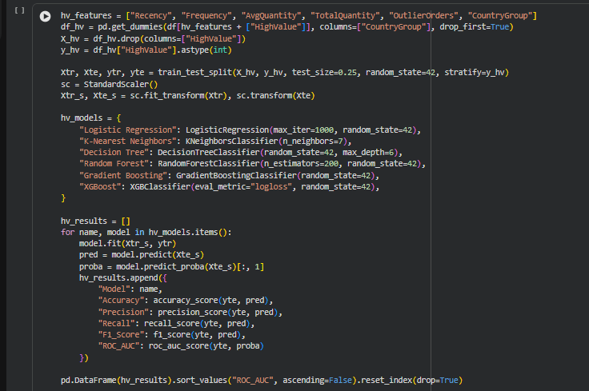
Output:
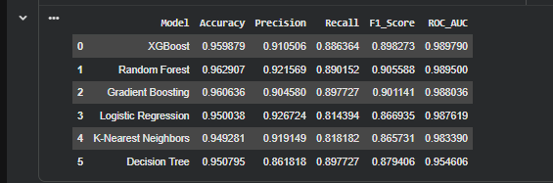
Even without them, all six models demonstrate an accuracy of over 94%. Both XGBoost and Random Forest achieve a ROC-AUC of 0.990.
This indicates that features such as the frequency and quantity of purchases contain sufficient information to differentiate between high and low customers even when the former’s total spendings are not explicitly provided to the model.

4.5 Customer Segment Classification

Five algorithms were applied to the four-class segment label. XGBoost requires class labels to start at zero, so the K-Means cluster numbers (1 to 4) were shifted down by one. Macro-averaged metrics were used so that each segment carries equal weight, regardless of its size. XGBoost achieved the best macro F1 score of 0.961.
Code:
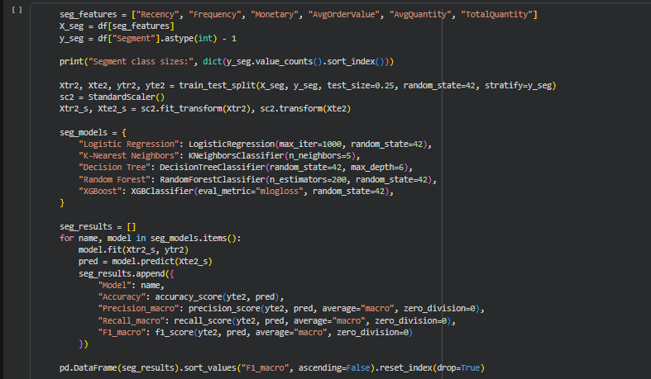
Output:
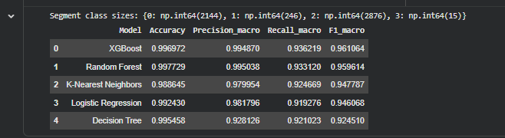
The high scores of model classification accuracy need to be put in perspective. The segment labels were identified using the same RFM variables that the model was later trained on. In essence, the model is simply learning the decision boundaries made by K-Means.
As such, the model's accuracy should not be considered an indicator of its ability to generalize to new data but rather its ability to re-classify the same data without the need to perform the time-consuming clustering process.

4.6 Stacking Ensemble
A stacking model was formed with three best-performing churn models (as determined by the AUC). The predictions of these models were fed into a Logistic Regression model that acted as the final, or meta, model.
Code:
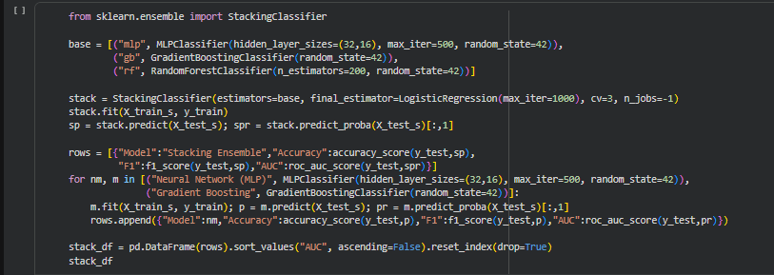
Output:
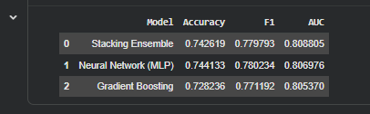
With a ROC-AUC of 0.809, the stacking approach performed only slightly better than the individual neural network model (0.807). Nevertheless, a minor improvement was achieved through the ensemble approach.

5. Hyperparameter Tuning and Model Optimization
Three complementary optimisation methods were applied: searching the hyperparameter space, moving the classification threshold, and rebalancing the training data.

5.1 Grid Search with Cross-Validation

GridSearchCV was used to test different combinations of parameters for Gradient Boosting and Logistic Regression. 3-fold cross-validation was used on the training set only, while ROC-AUC was used to compare the parameter sets.

The test set was held out for this procedure and the original and tuned results were compared to see if the additional tuning improved the results of the models.

Gradient Boosting
Code:
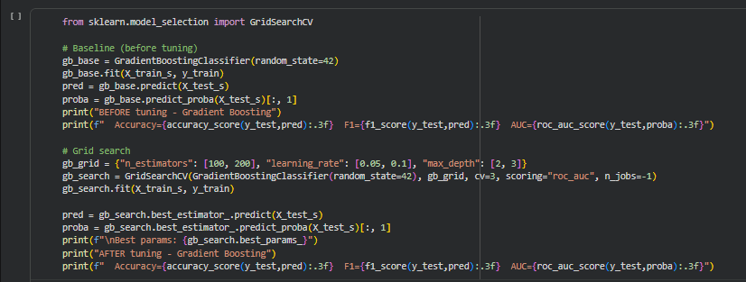
Output:
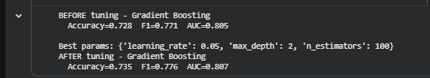

Logistic Regression
Code:
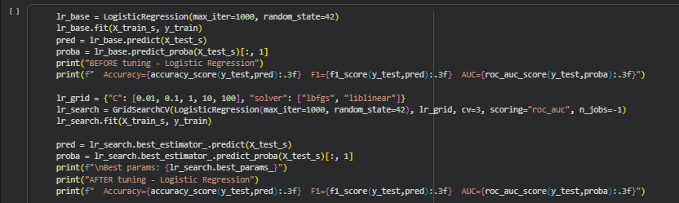
Output:
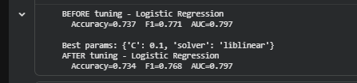
Gradient Boosting improved after tuning, with the final configuration using a learning rate of 0.05, maximum depth of 2 and 100 estimators. Logistic Regression showed very little change after tuning.
This was useful because it showed that tuning does not automatically improve every model. In this case, the tree-based model had more scope for improvement than the linear model.

5.2 Decision Threshold Optimization
The default classification threshold was 0.5. Since the primary objective of churn prediction is to identify customers who may leave, a second threshold was tested.
Code:
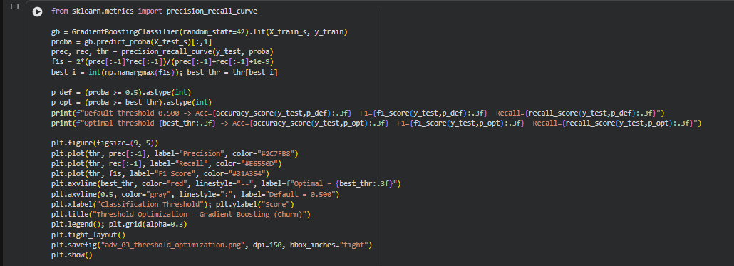
Output:
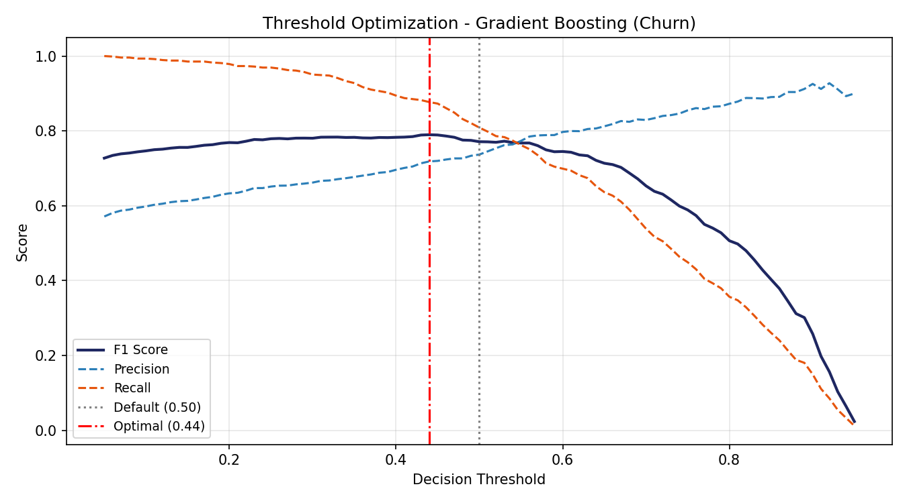
Threshold | Accuracy | F1 Score | Recall
0.500 (default) | 0.728 | 0.771 | 0.809
0.453 (optimised) | 0.739 | 0.791 | 0.873
Table 9: Effect of threshold optimisation on Gradient Boosting

The threshold was cut to 0.453. As a result, the recall rose from 0.809 to 0.873, while the F1-score climbed from 0.771 to 0.791 and the accuracy increased from 0.728 to 0.739.

It implies that the model can now identify more actual churners, but the number of false positives will be changed too.

5.3 Class Imbalance Handling with SMOTE
The HighValue target consists of considerably fewer high-value customers than regular customers. For this reason, SMOTE was tested to reduce the effect of imbalance.
SMOTE was applied only to the training data, while the original test data was left as is, so that the final evaluation reflected the true class distribution.
Code:
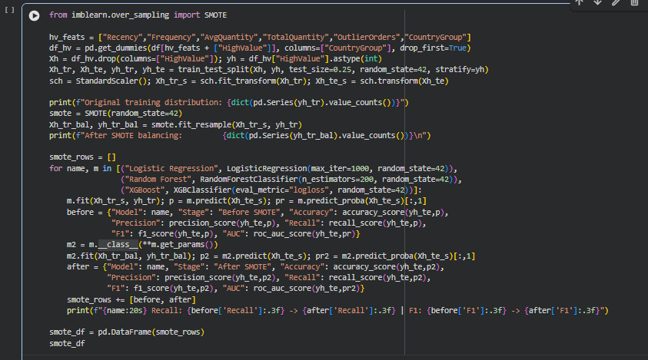
Output:
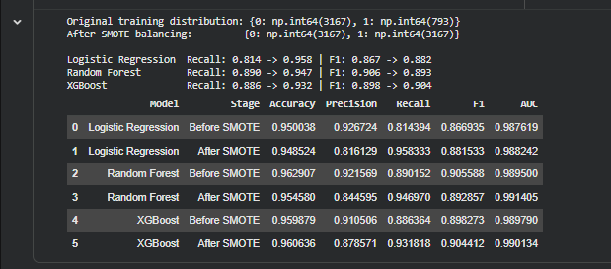
The change in minority-class recall is compared visually below.
Code:
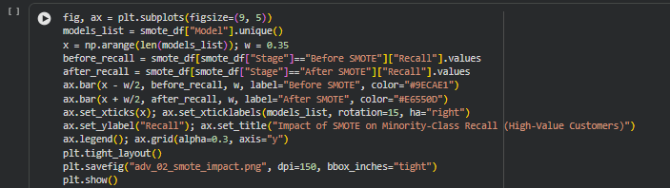
Output:
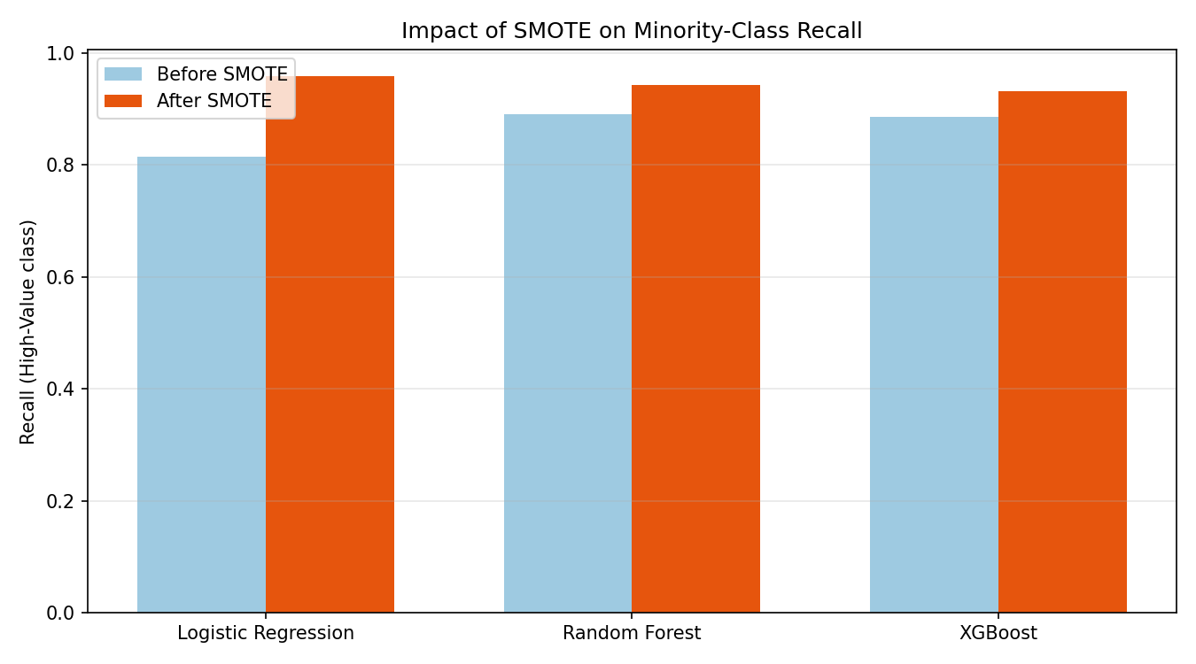

The minority class in the training set increased from 793 samples to 3,167 synthetic-balanced samples. The recall improved for all three models, with the highest increase for the Logistic Regression, which increased from 0.814 to 0.958. For the Random Forest, the higher recall came with a lower precision, thus, its F1-score decreased slightly.

6. Comparative Performance Analysis

The models were compared using multiple evaluation criteria instead of only accuracy. Additionally, the procedure of cross-validation was used to ensure that the results are stable enough regardless of the data split. Finally, the comparison also includes the McNemar’s test, which evaluates whether the difference in predictions between two algorithms is statistically significant.

6.1 Evaluation Metrics
Metric | Definition | Interpretation for Churn
Accuracy | (TP + TN) / all predictions | Share of customers classified correctly
Precision | TP / (TP + FP) | Share of flagged customers who actually churn
Recall | TP / (TP + FN) | Share of actual churners who are identified
F1 Score | Harmonic mean of precision and recall | Balance between false alarms and misses
ROC-AUC | Area under the ROC curve | Ability to rank churners above non-churners, independent of threshold
Average Precision | Area under the precision-recall curve | Ranking quality with emphasis on the positive class
Table 10: Evaluation metrics used in this report

The ROC-AUC served as the main metric for the final model ranking, which is explained by its ability to consider all possible thresholds of classification. For this particular case, the recall’s importance is increased due to the consequences of false negatives in case of predicting customer churn. Therefore, a customer who will leave the company but was predicted to stay would incur higher losses than a customer who will stay but was predicted to leave.

6.2 Consolidated Model Comparison
Task | Models Tested | Best Model | Key Metric | Score
Churn | 13 + ensemble | Stacking Ensemble | ROC-AUC | 0.809
Churn (single model) | 13 | Neural Network (MLP) | ROC-AUC | 0.807
Churn (tuned) | 2 | Gradient Boosting, threshold 0.453 | Recall / F1 | 0.873 / 0.791
High-Value | 6 | XGBoost / Random Forest | ROC-AUC | 0.990
High-Value (SMOTE) | 3 | Logistic Regression | Recall | 0.958
Segment | 5 | XGBoost | Macro F1 | 0.961
Table 11: Best-performing model for each task
Model | True Negatives | False Positives | False Negatives | True Positives
Neural Network (MLP) | 383 | 190 | 148 | 600
Gradient Boosting | 357 | 216 | 143 | 605
Logistic Regression | 388 | 185 | 163 | 585
Random Forest | 363 | 210 | 157 | 591
Table 12: Confusion matrix counts for the four leading churn models (test set of 1,321 customers)

The presented confusion matrices demonstrate that all four models have different numbers of false-negative and false-positive cases. Overall, Gradient Boosting has 143 false negatives, while Logistic Regression has 185 false positives. In turn, the Neural Network has 148 false negatives and 190 false positives.

Therefore, it can be concluded that the values depend on how much a researcher wants to miss some customers who churn and how many extra customers they want to attract with a promotion. Hence, an adequate balance should be chosen depending on specific intentions and purposes.

6.3 Cross-Validation Stability
A single train-test split can sometimes give a result that depends on the particular customers included in each part. To check this, five-fold stratified cross-validation was performed.
Code:
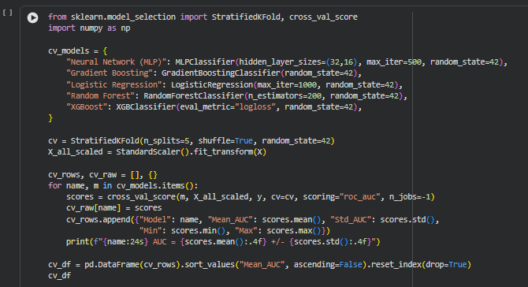
Output:
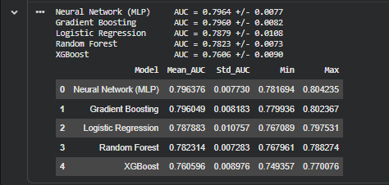
The spread of scores across the five folds is shown below.
Code:
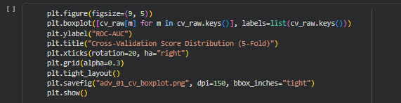
Output:
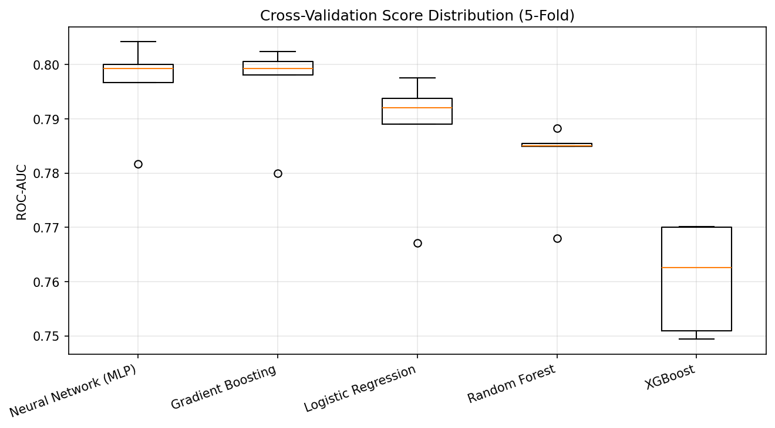
The standard deviations for the folds were under 0.011. As such, the results were fairly consistent across the five splits, and the overall ordering of the stronger models was similar to the original test-set results.
6.4 Statistical Significance Testing
The neural network outperformed Gradient Boosting by a relatively small margin. McNemar’s test examines the two models’ predictions on the same test customers to determine if their error difference is greater than what chance alone might explain.
Code:
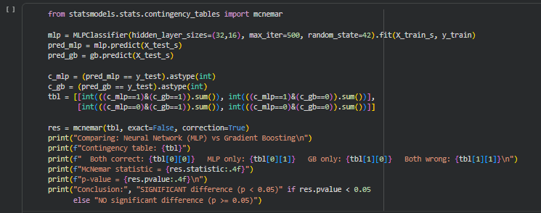
Output:
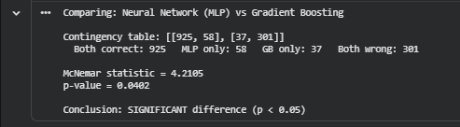
The neural network was correct on 58 customers that Gradient Boosting misclassified, versus 37 in the other direction. At a p-value of 0.040, the difference is significant at the 5% level, but not by much; either model would be defensible in practice, but the neural network's advantage is unlikely to be due to chance.

6.5 Key Observations
- Performance is limited more by the features than by the algorithm: ten of the thirteen churn models fall within four percentage points of ROC-AUC.
- Boosting ensembles and the neural network perform best on churn, while single decision trees and K-Nearest Neighbors perform worst.
- Threshold optimisation delivered a larger practical improvement (+0.064 recall) than hyperparameter tuning (+0.002 ROC-AUC).
- High-value status can be predicted with over 96% accuracy from behaviour alone, without spend-based features.
- Results are stable across folds, and the leading model's advantage is statistically significant.

7. Comparative Visualizations

While the numerical summaries are useful to indicate general trends, they do not provide all the information required about the behaviours of the model. Additional plots were therefore drawn to explore the models further.

ROC curves, precision-recall curves and confusion matrices were drawn to compare classification performance. Feature importance and Shapley values plots were drawn to understand the inputs, and learning and calibration curves were drawn to understand model behaviours beyond the summaries described in the previous section.

7.1 ROC Curves
ROC curves were plotted for six representative churn models, using the same test dataset. The curves show how the true-positive rate varies with the threshold used in classification.
Code:
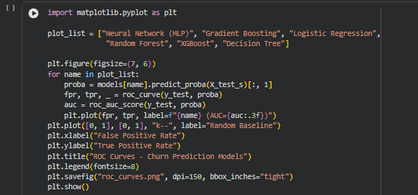
Output:
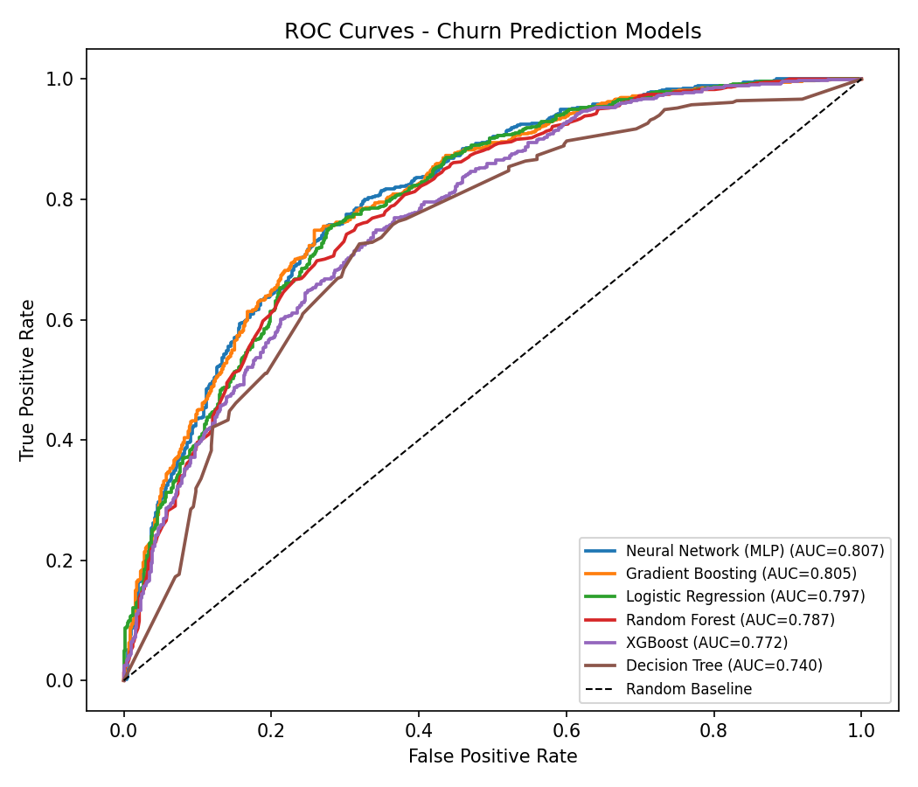
All curves lie well above the diagonal baseline, with those of the stronger models being closest to each other, as can be seen from the ROC-AUC values mentioned earlier, and the decision tree has the lowest curve.

7.2 Precision-Recall Curves
Precision-recall curves were plotted to analyze the trade-off between precision and recall for different thresholds.
Code:
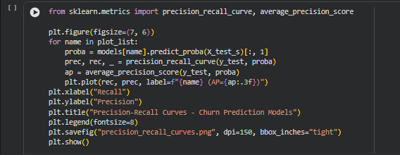
Output:
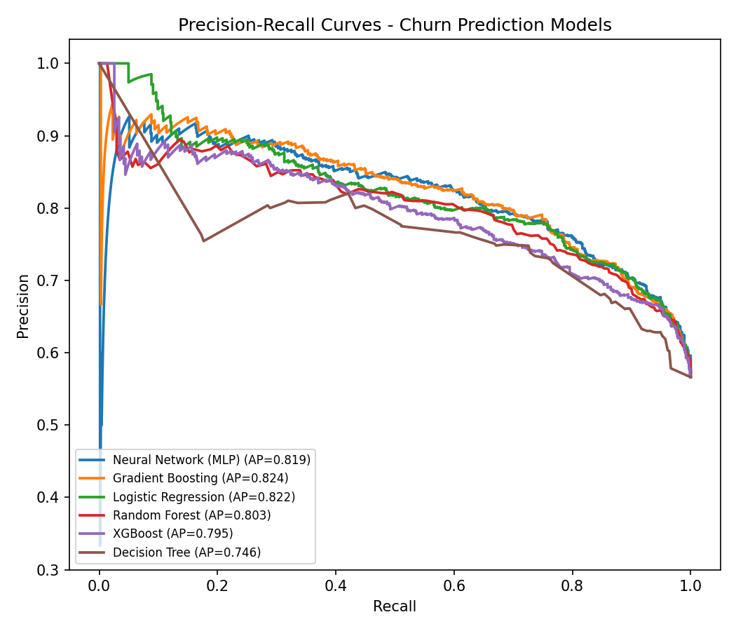
As precision generally decreases, recall increases. In this data set, the majority of the models have a precision above 0.75 until it reaches about 0.8. From this point on, there is an increase in false positives with higher recall.

7.3 Confusion Matrices
Confusion matrices were created for the four main churn models using the default classification threshold.
Code:
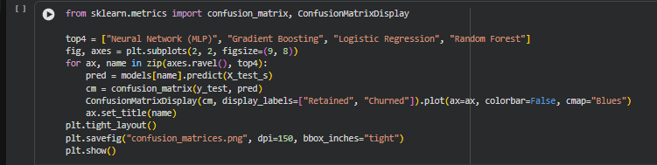
Output:
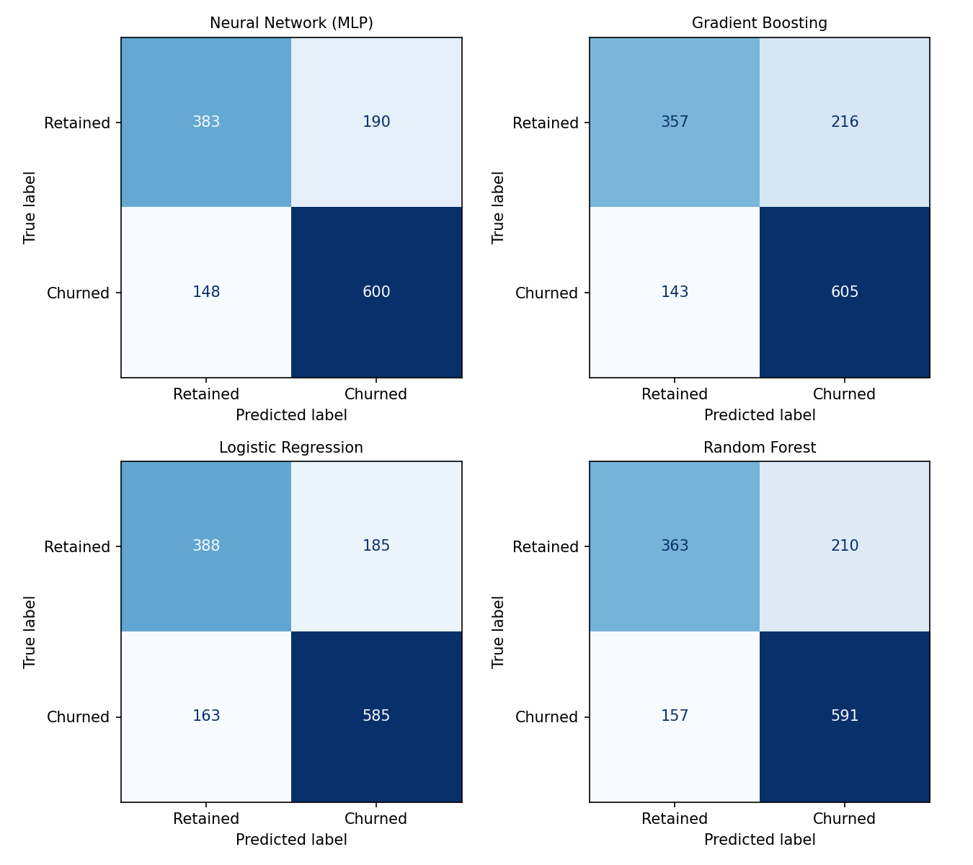

They allow to evaluate individual types of errors incorporated in the overall accuracy metric. In the results, all four models showed a higher number of false positives than false negatives at the default threshold.

7.4 Feature Importance
The importance of features was evaluated for the Random Forest and XGBoost algorithms to assess which predictors contributed the most to the training process.
Code:
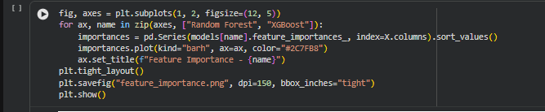
Output:
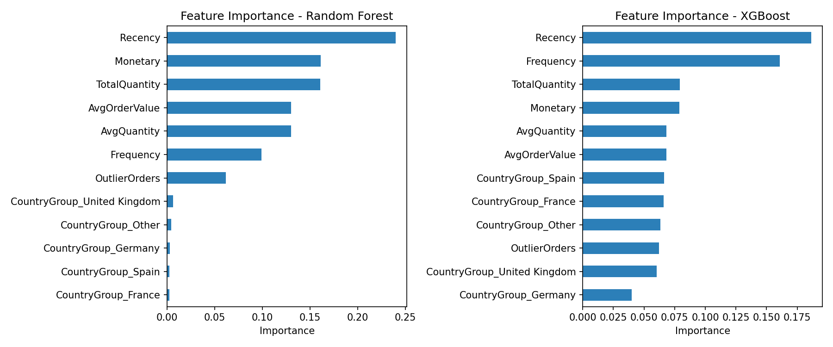

Recency was the most important feature, both in models, followed by Frequency and the quantity-related variables, while the country-based variables contributed significantly less compared with the main behavioural features.

7.5 SHAP Explainability
Feature importance provides an aggregated view of variable relevance, but does not explain how a variable impacts an individual customer. Therefore, SHAP values were used to investigate individual predictions.
Code:
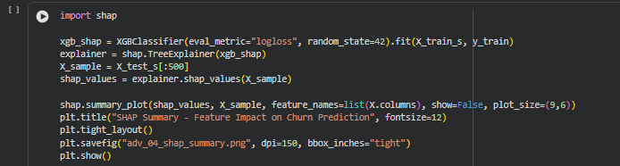
Output:
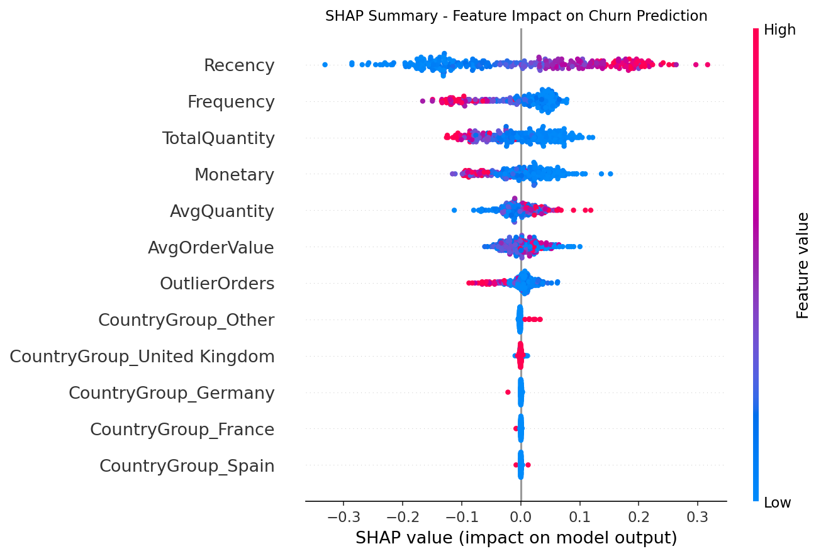
Each point represents one customer. The position of the point along the x-axis indicates the impact of the feature value on the customer’s prediction, with the color indicating whether the value was high or low. High values of Recency have a positive impact on the prediction, pushing it toward churn, whereas high values of TotalQuantity and Monetary have the opposite impact.
Consequently, the SHAP plots can be used to identify features that pushed a particular prediction toward a certain class. This is useful information, as the overall contribution of the feature to the model’s performance cannot always be seen in the feature importance list.
The mean absolute SHAP value can also be used to rank the features according to their influence.
Code:
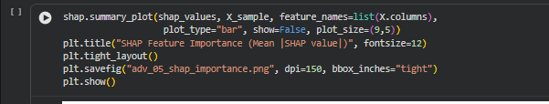
Output:
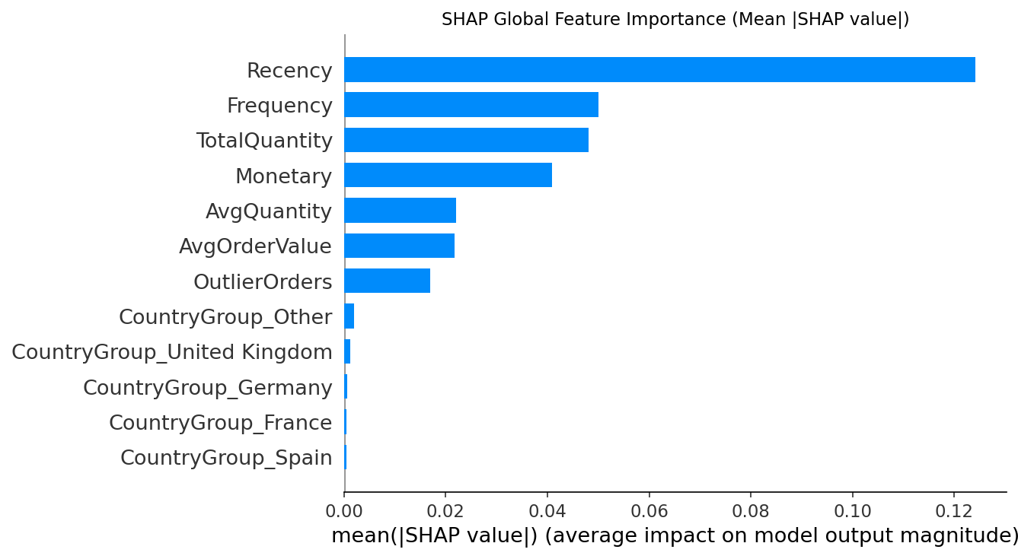

7.6 Learning Curves
Learning curves were built to evaluate training and validation performance of the model on a growing size of training sets.
Code:
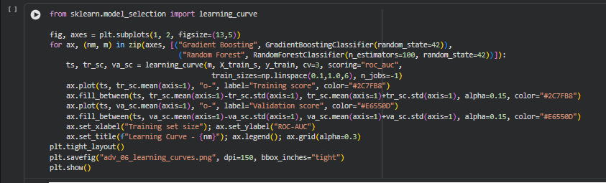
Output:
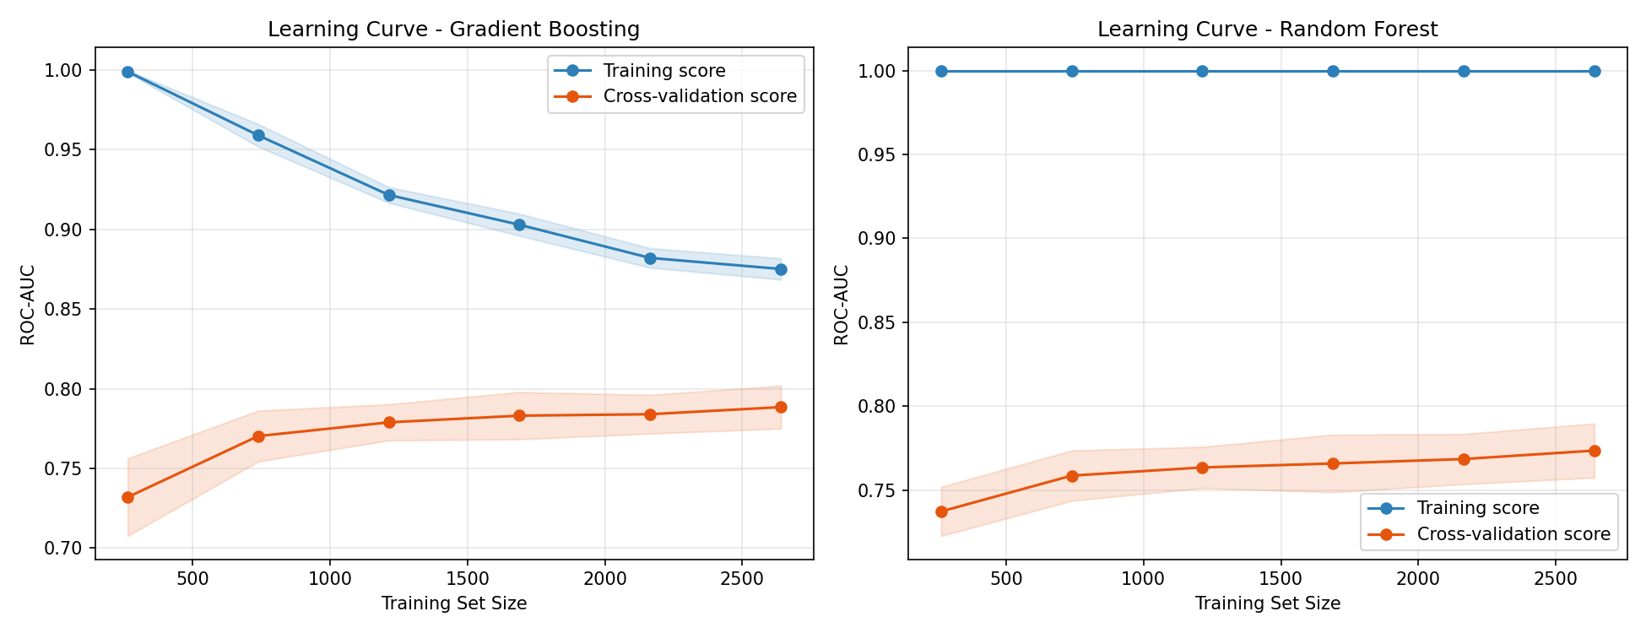
The Random Forest algorithm shows a significant difference between the scores of training and validation subsets. While the former keeps close to 1, the validation score is around 0.77, which indicates a considerable deviation. On the contrary, the two curves for the Gradient Boosting algorithm are relatively close to each other, which means that the training and validation errors are on the same level.

7.7 Probability Calibration
A calibration curve was plotted to check if the predicted probabilities of the model match actual outcomes in the data.
Code:
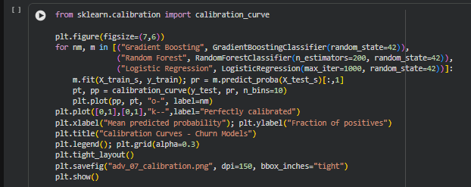
Output:
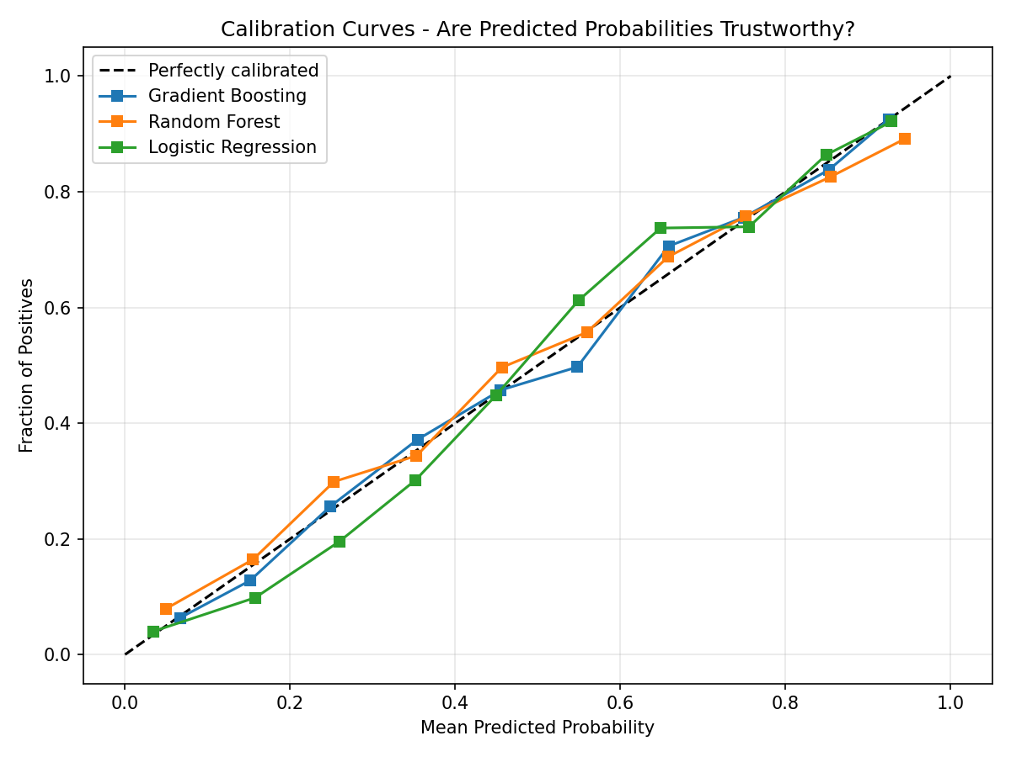
For example, a group of customers that obtains a predicted churn probability of about 70% must have 70% of its customers who churn according to a well-calibrated model. This information conveys additional insights than accuracy or ROC-AUC, which is relevant when the probabilities are used to determine how much retention effort needs to be put for each customer.
7.8 Customer Segment Visualization
The four clusters are defined on six dimensions, which cannot be visualized directly. Principal component analysis reduces the data to two components according to [3], making the segments accessible to visualization.
Code:
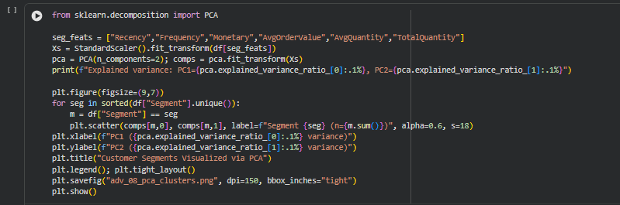
Output:
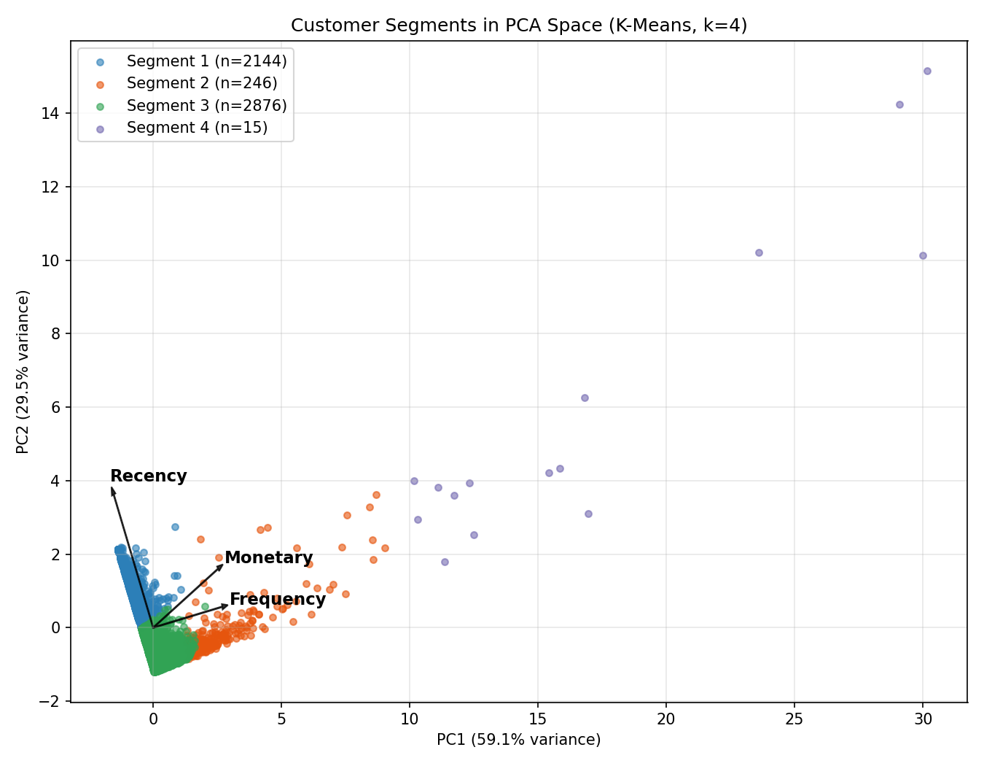
The two components retain 45.0% and 22.2% of variance, which preserves about two-thirds of the structure in a form amenable to visual inspection. The segments are clearly differentiated, especially the small high-value clusters to the right.
A heatmap over the mean feature values facilitates interpretation of the segments.
Code:
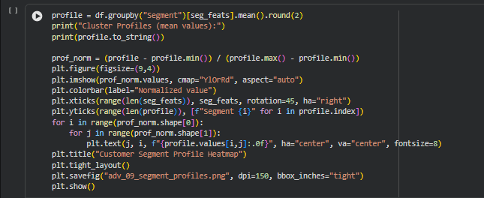
Output:
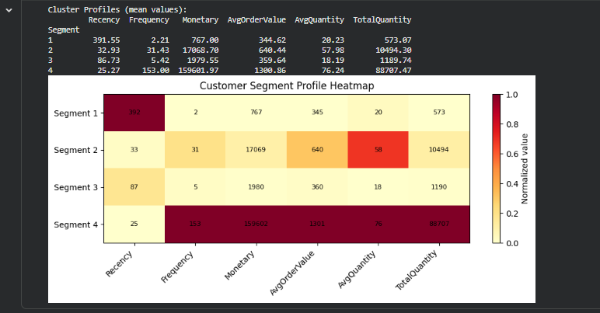
Segment | Customers | Avg Recency (days) | Avg Frequency | Avg Monetary (GBP) | Interpretation
1 | 2,144 | 392 | 2.2 | 767 | Dormant, largely lost
2 | 246 | 33 | 31.4 | 17,069 | Loyal high spenders
3 | 2,876 | 87 | 5.4 | 1,980 | Active regular buyers
4 | 15 | 25 | 153.0 | 159,602 | Elite wholesale accounts
Table 13: Profile and interpretation of each customer segment
The clusters represent distinct types of customers. Segment 4 is made up of fifteen wholesale accounts worth nearly GBP 160,000 on average; these are mostly the customers whose large orders were flagged, not discarded in DA1.

8. Demonstration of Business Output
The end product is predictions at a customer level, which can be combined with the existing customer information.
The results of the predictions in Python were written back into the SQLite database. This allows the use of SQL to select customers based on their predicted churn risk and historical value.
Code:
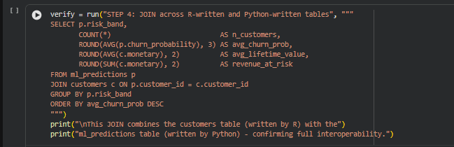
Output:
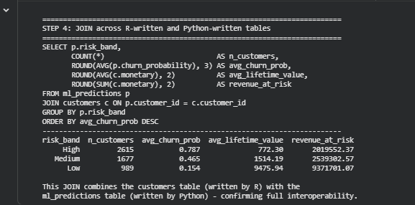
Approximately GBP 2.02 million of historical revenue belongs to customers the model identifies as likely to churn. In addition, average lifetime value increases steeply as risk decreases so that the model’s ordering reflects commercial value too.
The second query isolates the most valuable customers within the high-risk group to create a retention target list directly.
Code:
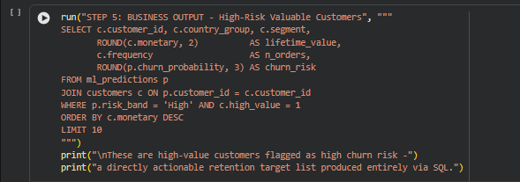
Output:
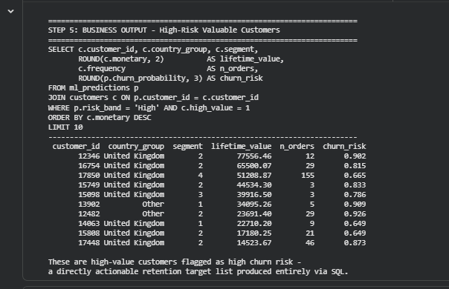

The final query is an example of how the results of the model could be used for further investigation of customers. A high probability of churn should not be acted upon alone, but in combination with a high lifetime value it should. Customer 12346, for example, has been paying over GBP 77,000 and has a 90% probability of not returning.

9. Conclusion
This phase extended the work completed in DA1 by transforming the cleaned transaction data into customer-level information that could be leveraged for prediction and segmentation. R was used for feature engineering and database preparation, while Python was applied to model training, evaluation and SQL-based analysis.

The RFM features provided the primary description of customer behaviour. A time-based approach was applied to the churn target to ensure that information from the future was not incorporated as input features. It was an important change as compared to the first modelling attempt, where the churn rule was directly related to Recency and resulted in 100% accuracy due to data leakage.

Twenty-four models were tested across churn, high-value customer prediction and customer segment classification. In the case of the churn task, the Neural Network obtained a ROC-AUC of 0.807, while the stacking model reached 0.809. Thus, changing the classification threshold increased the recall from 0.809 to 0.873. Additionally, SMOTE was tested for the HighValue task and improved the minority-class recall of Logistic Regression to 0.958.
The analysis also revealed that Recency and Frequency were important features for the churn models. While the SHAP analysis provided a more detailed perspective on the effects on the features on the individual predictions, the learning curves highlighted significant overfitting in the Random Forest model.

The database component of the project was used throughout the workflow, not only as a storage medium, but also as a computational layer. Data was transferred from R to SQLite, read by Python for modelling and the final predictions were written back into SQLite, which enabled joining the model results with customer information through SQL.

Overall, the phase produced a complete workflow ranging from customer-level feature creation and model training through to model predictions stored in the database. The remaining work is primarily focused on combining the outputs, discussing limitations and preparing the final project presentation.

10. References
- Rungruang, C., Riyapan, P., Intarasit, A., Chuarkham, K., & Muangprathub, J. (2024). RFM model customer segmentation based on hierarchical approach using FCA. Expert Systems with Applications, 237, 121449. https://doi.org/10.1016/j.eswa.2023.121449
- Christy, A. J., Umamakeswari, A., Priyatharsini, L., & Neyaa, A. (2021). RFM ranking - An effective approach to customer segmentation. Journal of King Saud University - Computer and Information Sciences, 33(10), 1251-1257. https://doi.org/10.1016/j.jksuci.2018.09.004
- Quelal, A., Amaro, I., & Chamorro, K. (2024). Customer segmentation in online retail using K-Means clustering classification and principal component biplot. Springer. https://link.springer.com/chapter/10.1007/978-3-031-54235-0_3
- Arefin, S., Parvez, R., Ahmed, T., Ahsan, M., Sumaiya, F., Jahin, F., & Hasan, M. (2024). Retail industry analytics: Unraveling consumer behavior through RFM segmentation and machine learning. In 2024 IEEE International Conference on Electro Information Technology (eIT), pp. 545-551. https://ieeexplore.ieee.org/document/10609927
- Xiahou, X., & Harada, Y. (2022). B2C e-commerce customer churn prediction based on K-Means and SVM. Journal of Theoretical and Applied Electronic Commerce Research, 17(2), 458-475. https://doi.org/10.3390/jtaer1700024
- Chen, D. (2012). Online Retail II [Dataset]. UCI Machine Learning Repository. https://doi.org/10.24432/C5CG6D
- Pedregosa, F., Varoquaux, G., Gramfort, A., et al. (2011). Scikit-learn: Machine learning in Python. Journal of Machine Learning Research, 12, 2825-2830.
- Chen, T., & Guestrin, C. (2016). XGBoost: A scalable tree boosting system. In Proceedings of the 22nd ACM SIGKDD International Conference on Knowledge Discovery and Data Mining, pp. 785-794. https://doi.org/10.1145/2939672.2939785
- Lundberg, S. M., & Lee, S.-I. (2017). A unified approach to interpreting model predictions. In Advances in Neural Information Processing Systems 30, pp. 4765-4774.
- Chawla, N. V., Bowyer, K. W., Hall, L. O., & Kegelmeyer, W. P. (2002). SMOTE: Synthetic minority over-sampling technique. Journal of Artificial Intelligence Research, 16, 321-357. https://doi.org/10.1613/jair.953
- McNemar, Q. (1947). Note on the sampling error of the difference between correlated proportions or percentages. Psychometrika, 12(2), 153-157.

